Task 1: Configure VPC Peering Across Regions (AWS)
Objective
Create a VPC Peering connection between two VPCs located in different AWS Regions and verify connectivity between resources in both VPCs.

Prerequisites
VPC Details
VPC | Region | CIDR
VPC-A | ap-south-1 (Mumbai) | 10.0.0.0/16
VPC-B | us-east-1 (N. Virginia) | 10.1.0.0/16
Important: CIDR blocks must not overlap.

Architecture
Region 1 (Mumbai)
--------------------------
VPC-A
CIDR: 10.0.0.0/16
Subnet: 10.0.1.0/24
EC2-A
|
| VPC Peering
|
EC2-B
Subnet: 10.1.1.0/24
CIDR: 10.1.0.0/16
VPC-B
--------------------------
Region 2 (Virginia)

Step 1: Create VPC-A
Navigate:
AWS Console
→ VPC
→ Create VPC
Configuration:
Name: VPC-A
Region: ap-south-1
CIDR:
10.0.0.0/16
Create subnet:
10.0.1.0/24
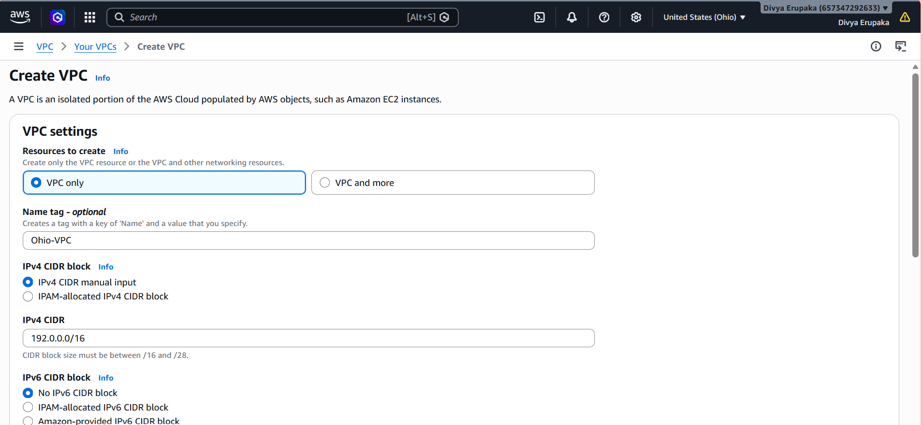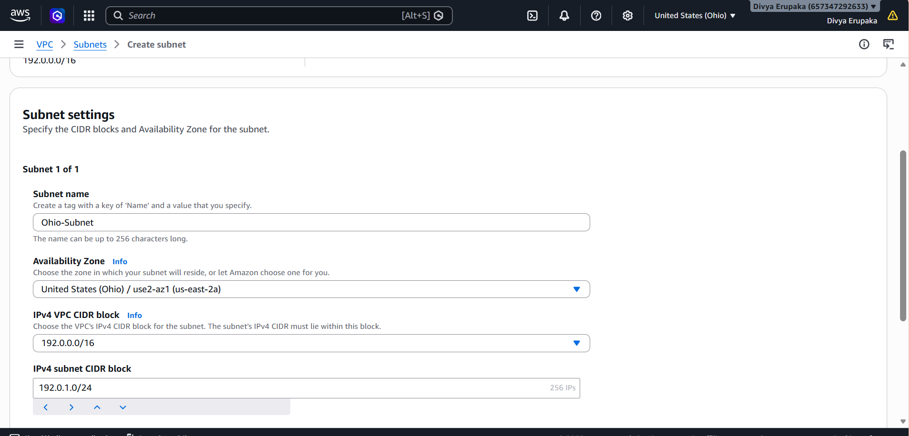
Step 2: Create VPC-B
Switch Region:us-east-1
Create:Name: VPC-B
CIDR:10.1.0.0/16
Create subnet: 10.1.1.0/24
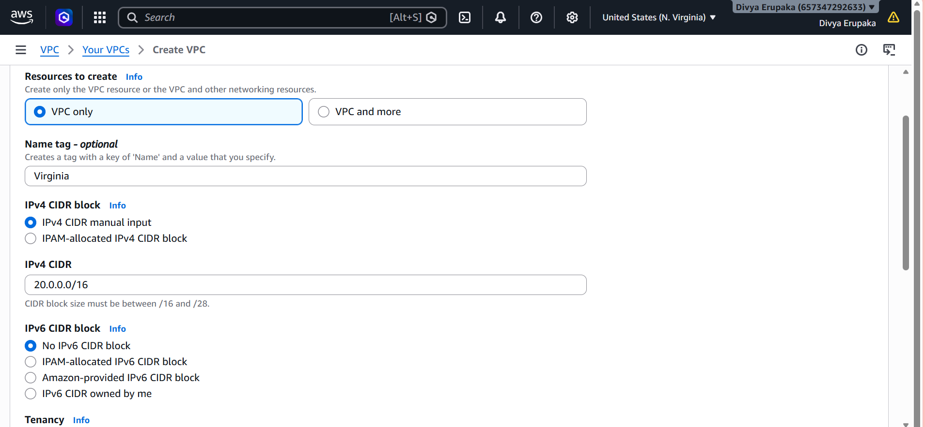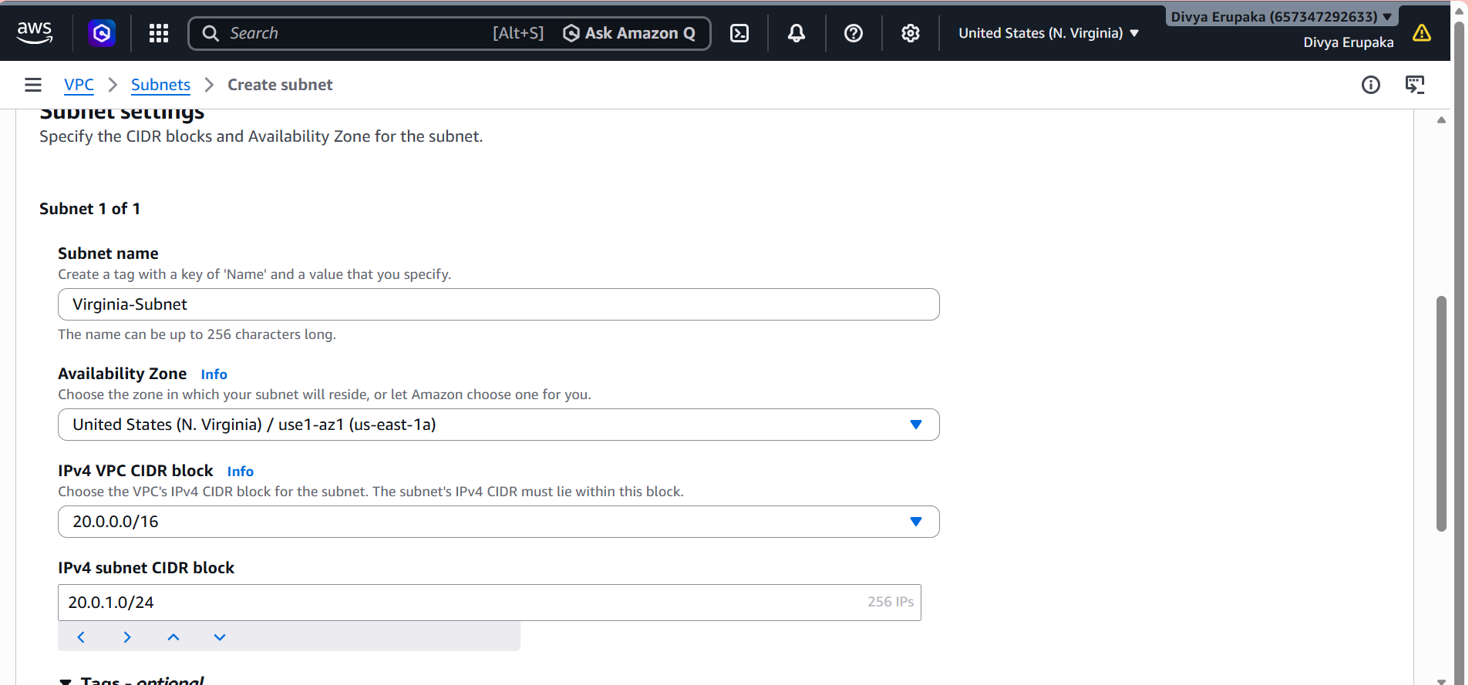

Step 3: Launch Test EC2 Instances
EC2-A in Mumbai
Region: ap-south-1
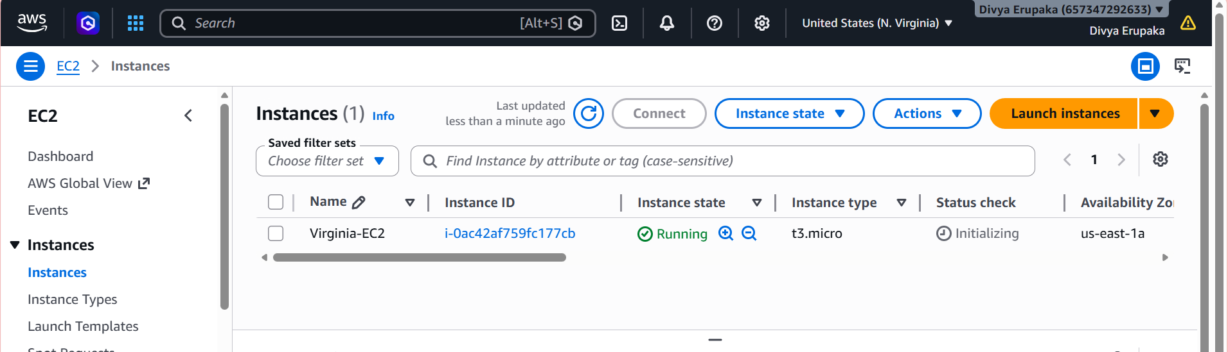
EC2-B in Virginia
Region: us-east-1
Subnet:
10.1.1.0/24
Private IP:
10.1.1.10
Use Amazon Linux 2 for both.
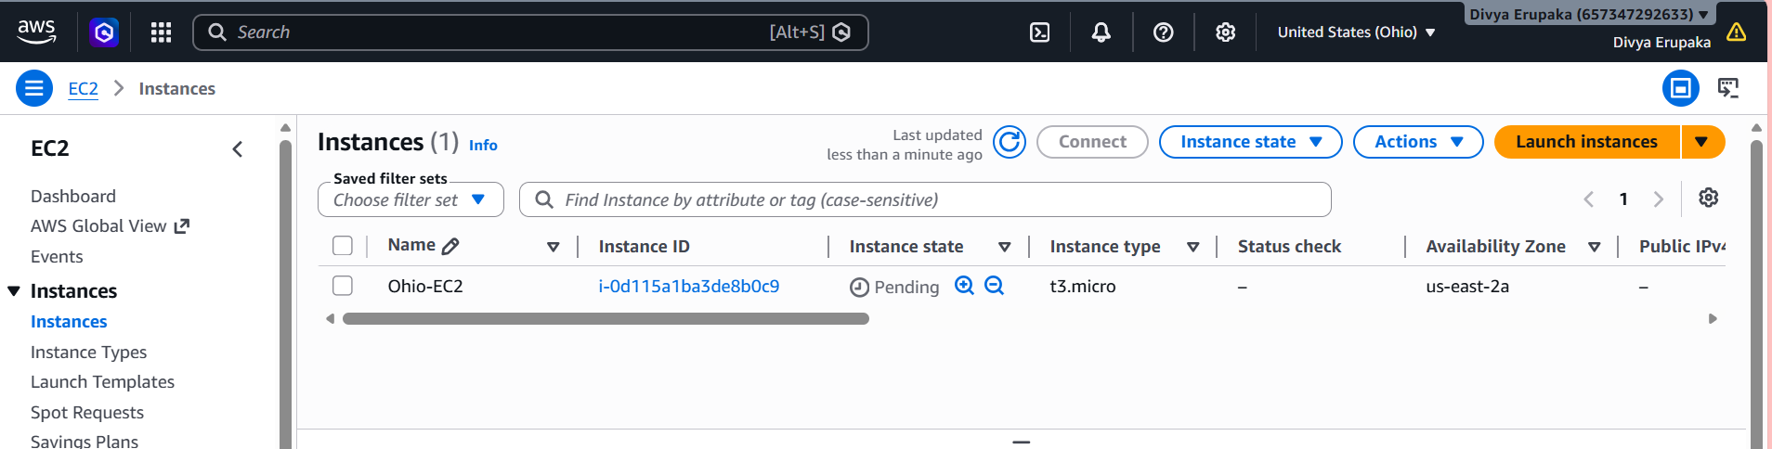
Step 4: Create VPC Peering Connection
Navigate:
VPC Console
→ Peering Connections
→ Create Peering Connection
Configuration:
Name:
Cross-Region-Peering
Requester VPC:
VPC-A (Mumbai)
Accepter VPC:
VPC-B (Virginia)
Accepter Region:
us-east-1
Click:
Create Peering Connection
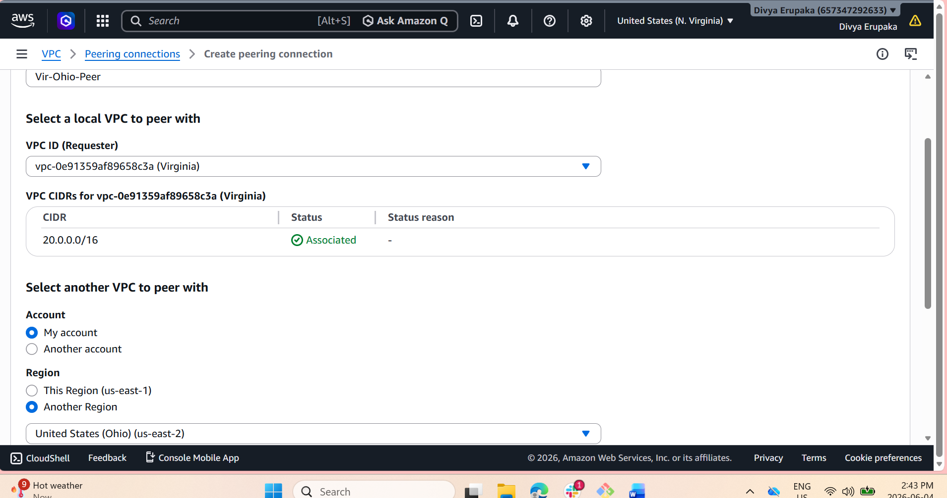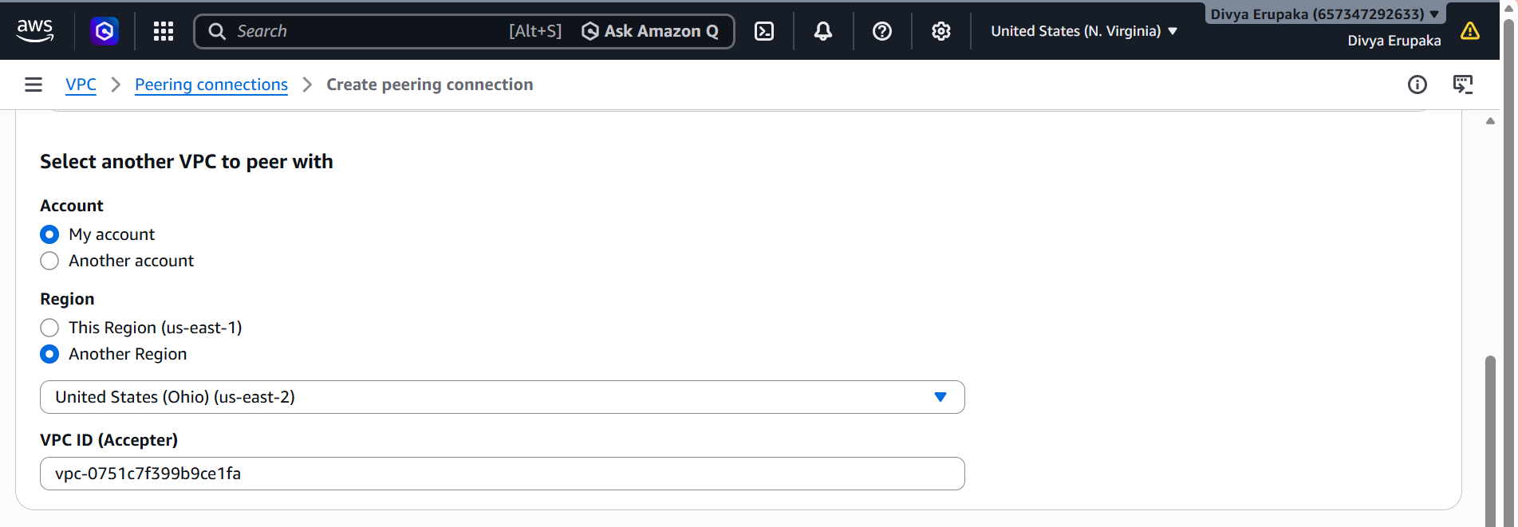
Step 5: Accept Peering Request
Switch to:
Region:
us-east-1
Navigate:
VPC
→ Peering Connections
Select pending request.
Click:
Actions
→ Accept Request
Status should become:
Active
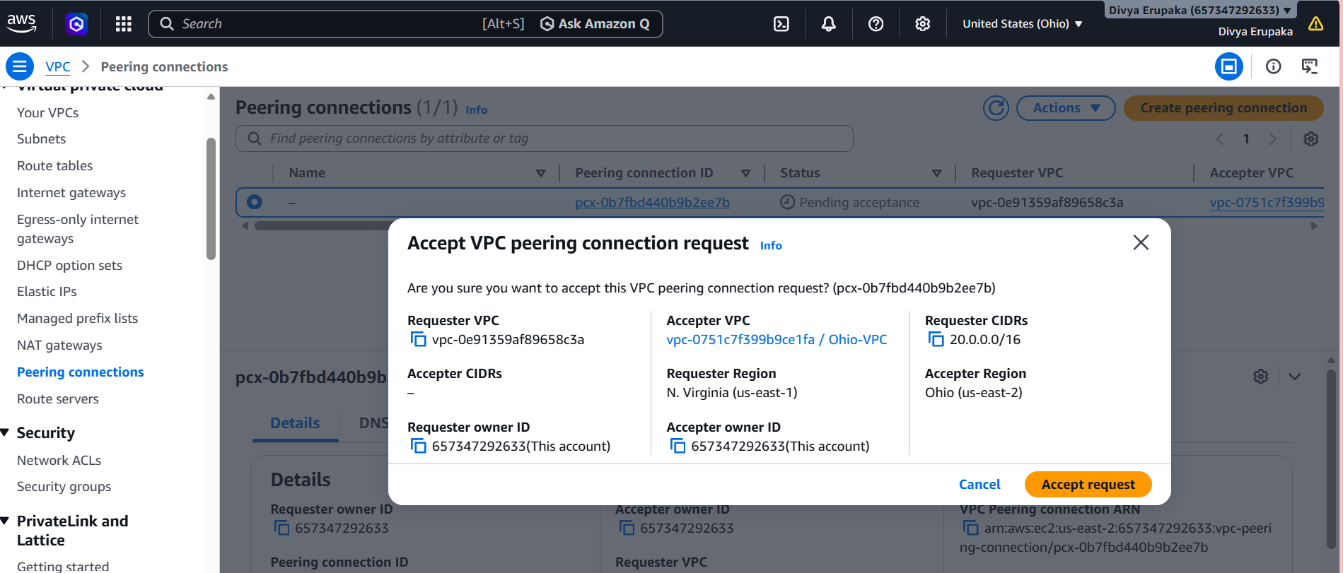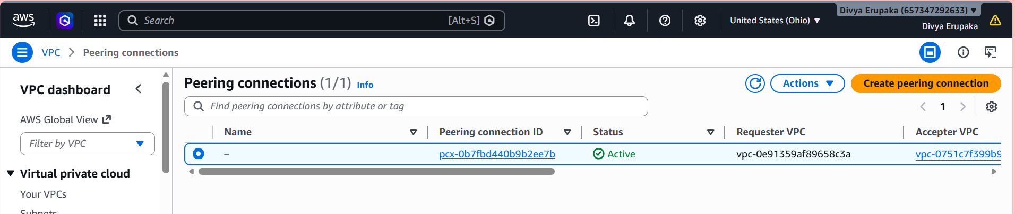
Step 6: Update Route Tables
Route Table of VPC-A
Navigate:
Route Tables
→ Select Route Table
→ Edit Routes
Add:
Destination:
10.1.0.0/16
Target:
Peering Connection (pcx-xxxxxx)
Save.
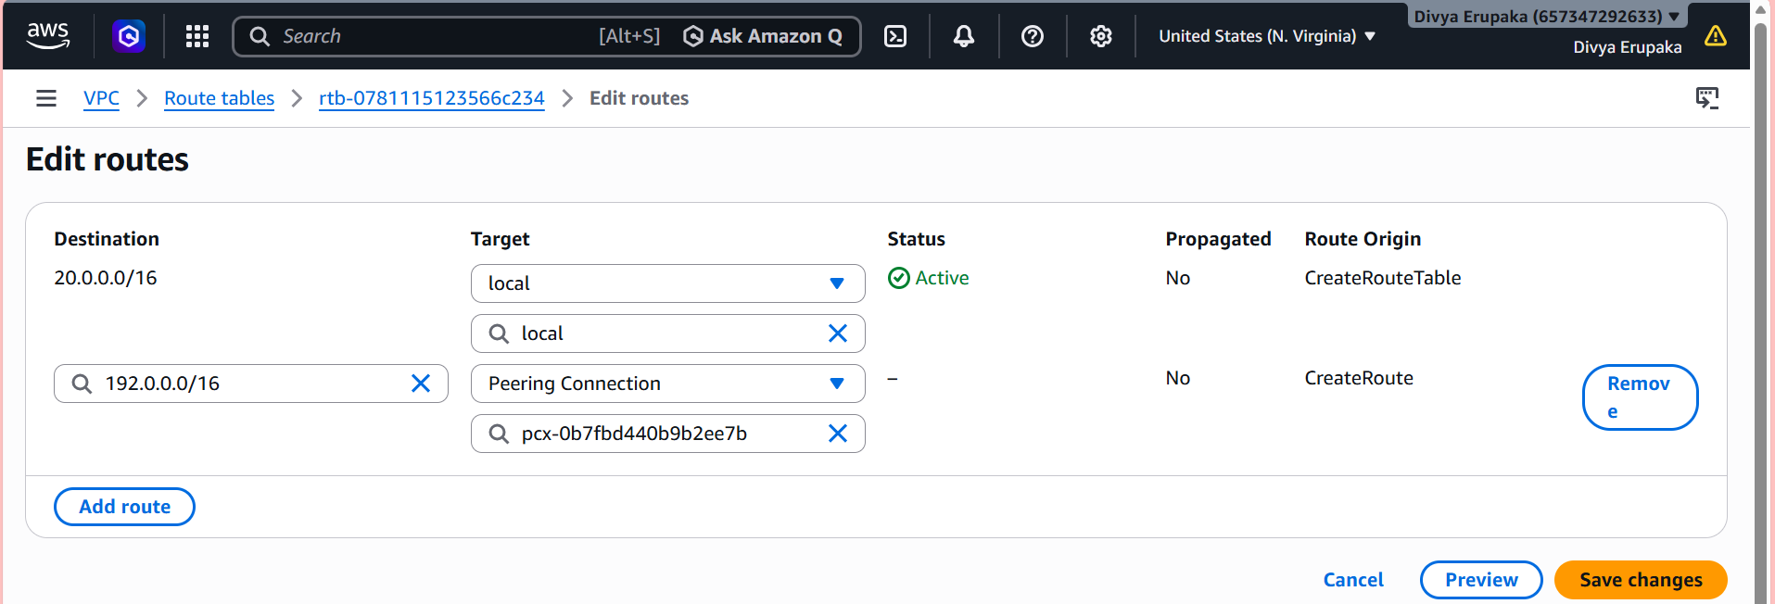
Route Table of VPC-B
Add:
Destination:
10.0.0.0/16
Target:
Peering Connection (pcx-xxxxxx)
Save.
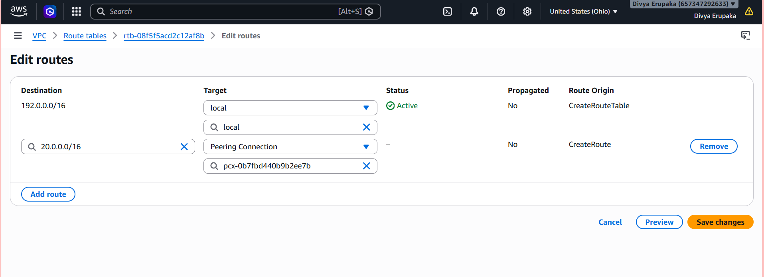
Step 7: Update Security Groups
Security Group for EC2-A
Add inbound rule:
Type:
All ICMP IPv4
Source:
10.1.0.0/16
Optional:
SSH
10.1.0.0/16
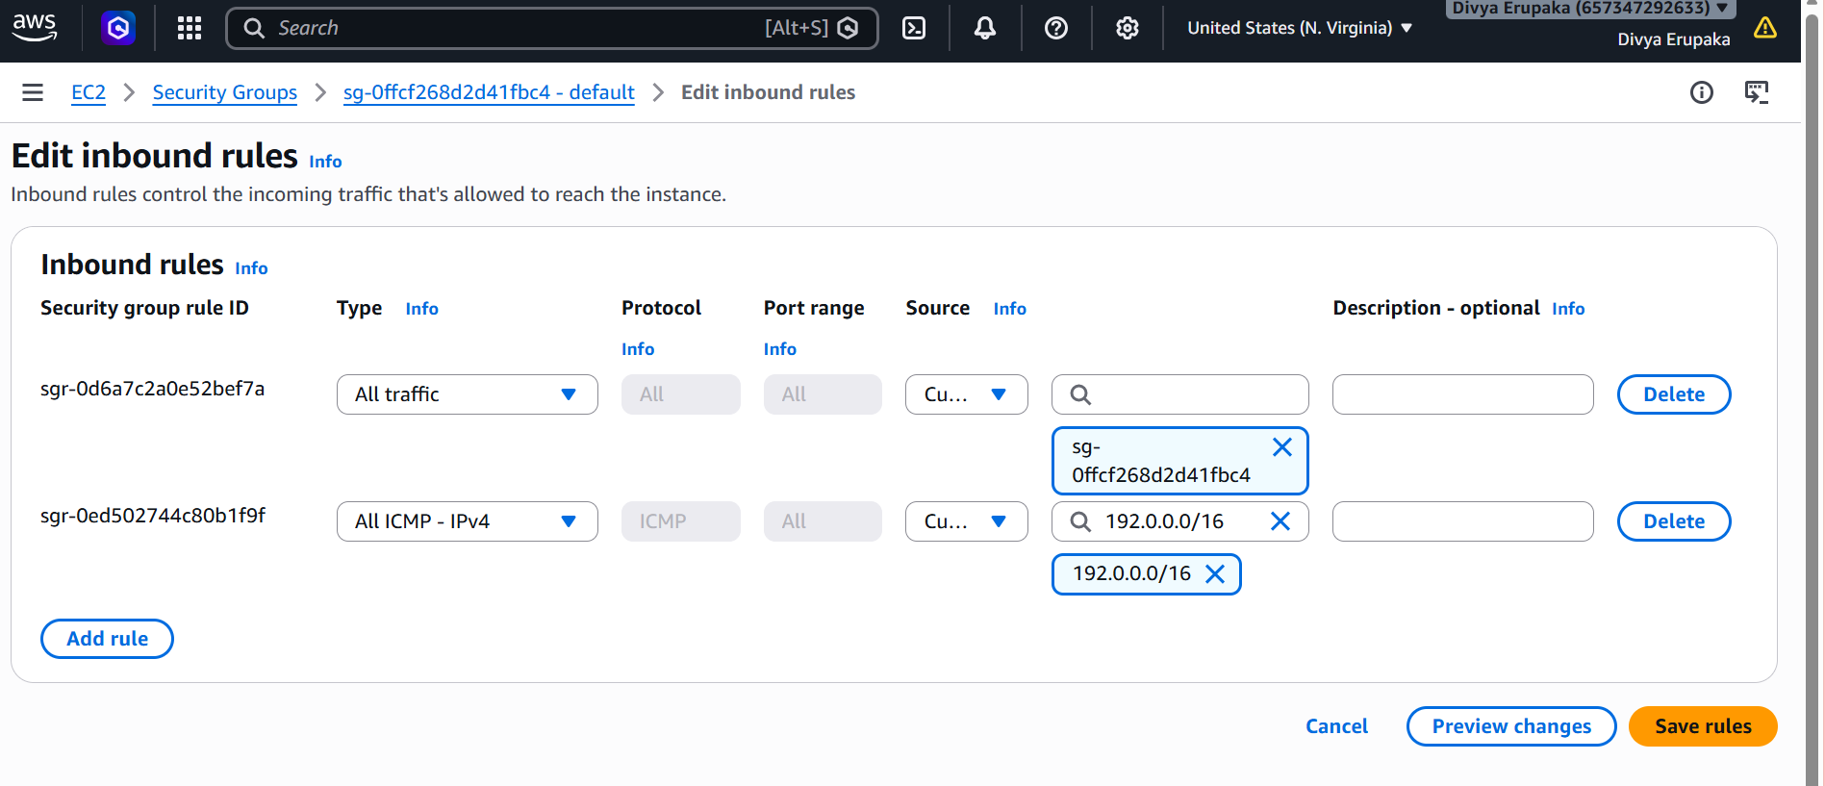
Security Group for EC2-B
Add:
Type:
All ICMP IPv4
Source:
10.0.0.0/16
Optional:
SSH
10.0.0.0/16
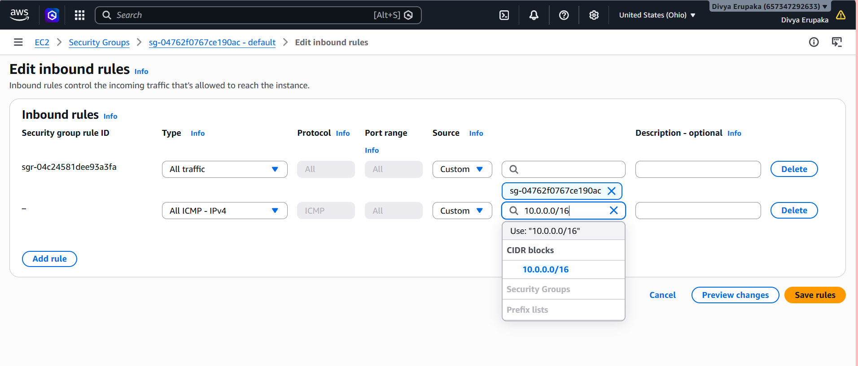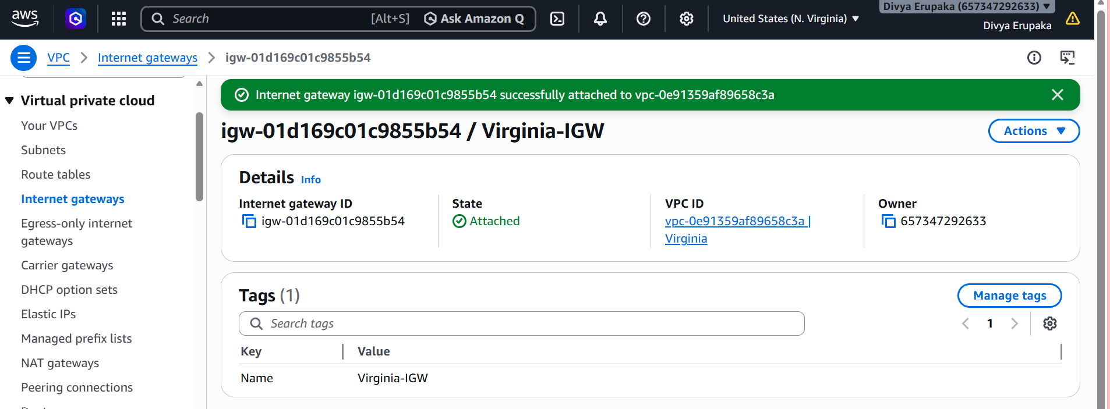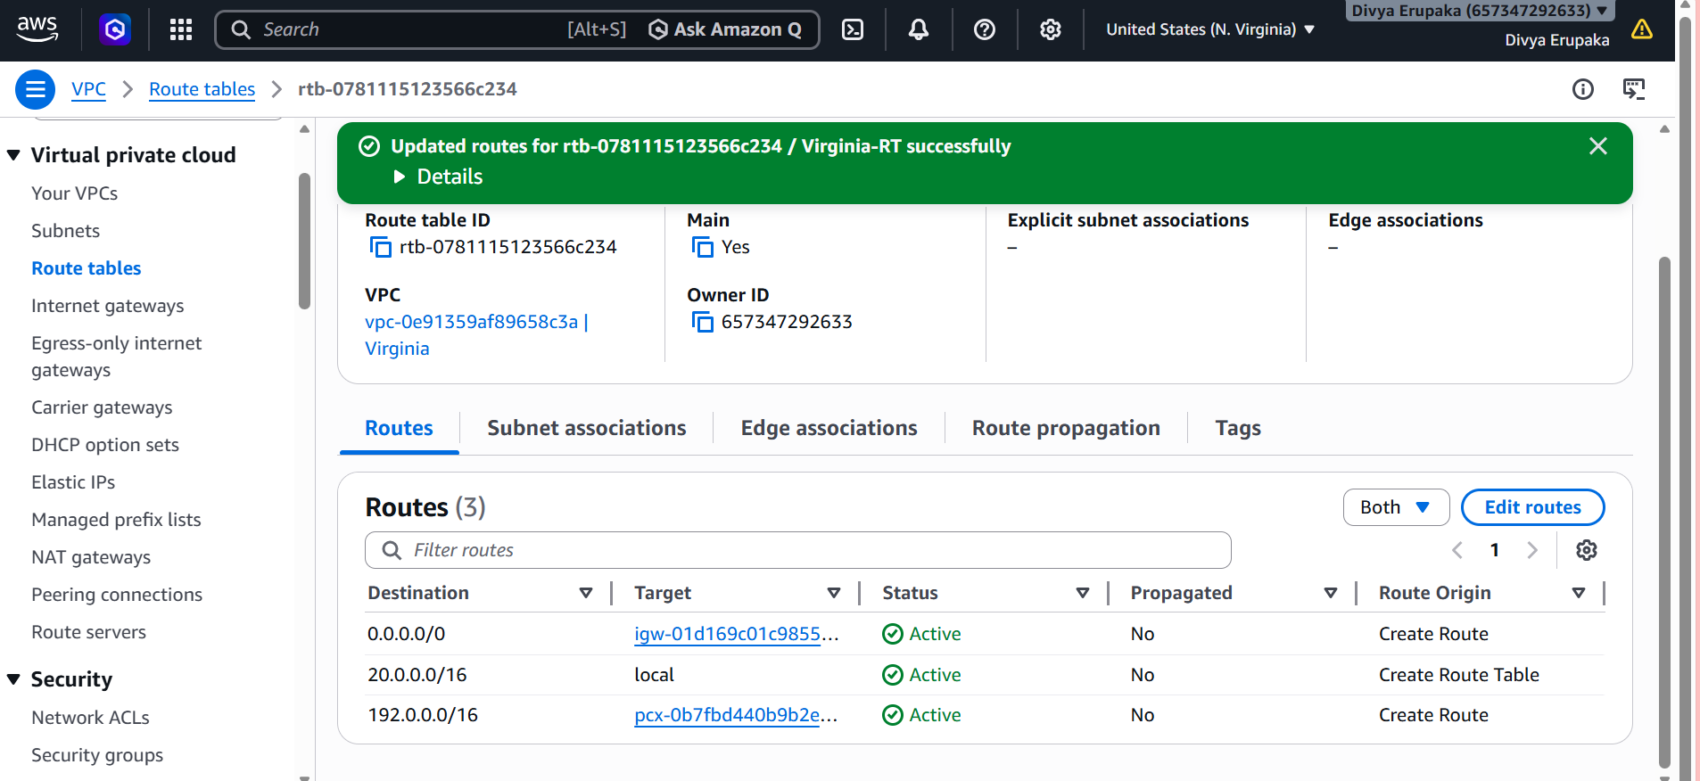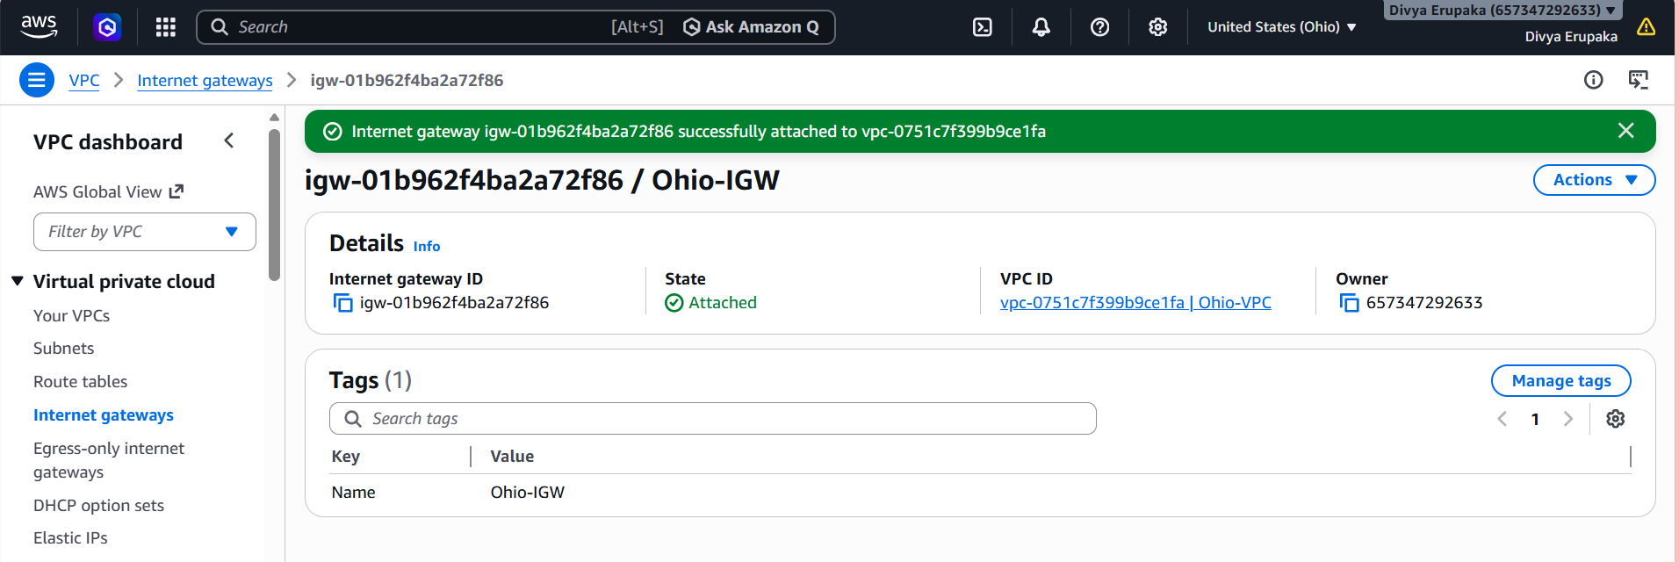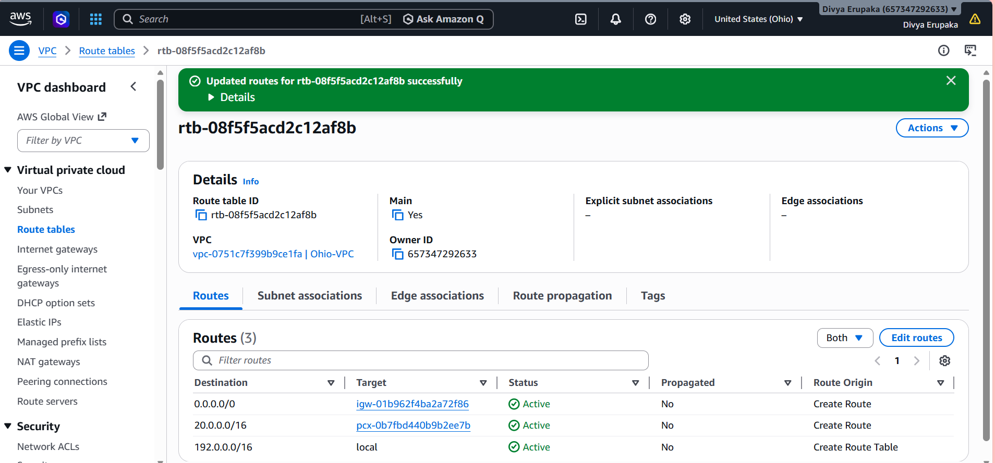
Step 8: Verify Connectivity
SSH into EC2-A.
Run:
ping 10.1.1.10
Expected:
64 bytes from 10.1.1.10

SSH into EC2-B.
Run:
ping 10.0.1.10
Expected:
64 bytes from 10.0.1.10

Step 9: Verify Route Tables
Check VPC-A route table:
Destination Target
10.0.0.0/16 local
10.1.0.0/16 pcx-xxxxxx
Check VPC-B route table:
Destination Target
10.1.0.0/16 local
10.0.0.0/16 pcx-xxxxxx

Validation Commands
From EC2-A:
ping 10.1.1.10
traceroute 10.1.1.10
From EC2-B:
ping 10.0.1.10
traceroute 10.0.1.10
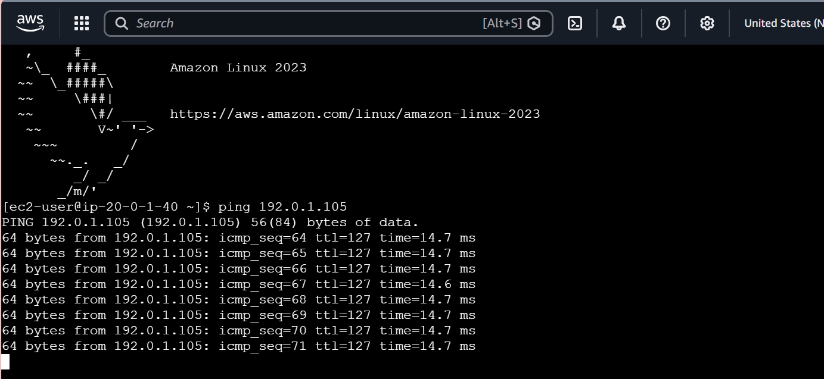
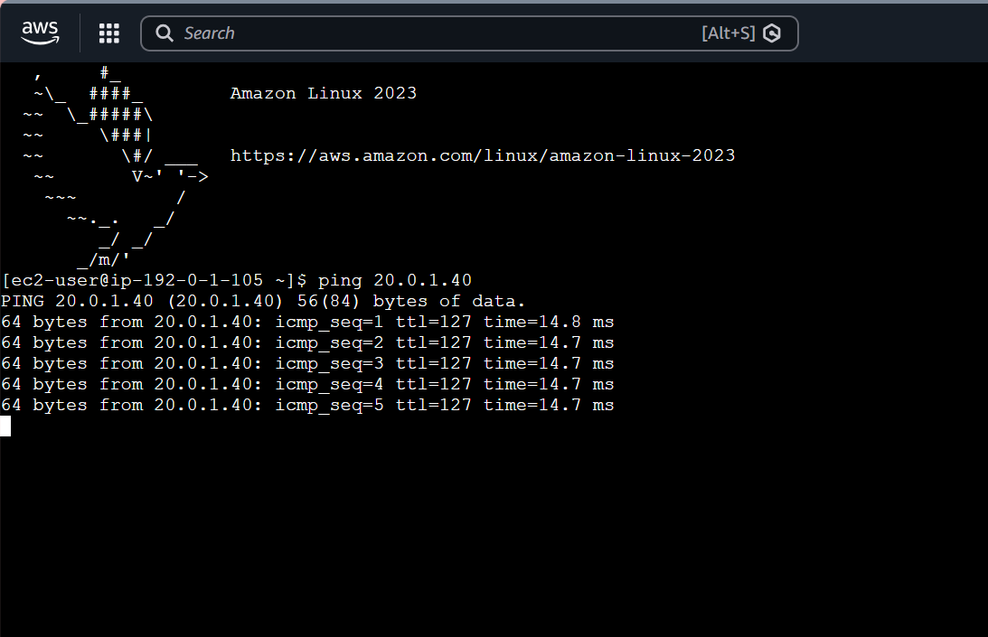
Task 2: Purchase a Domain from GoDaddy
Objective: Purchase a custom domain name from GoDaddy and prepare it for use with AWS Route 53 and CloudFront.

Prerequisites
- Valid email address
- Debit/Credit Card, UPI, Net Banking, or other supported payment method
- GoDaddy account

Step 1: Create a GoDaddy Account
Navigate to:
GoDaddy Official Website
- Click Sign In
- Select Create an Account
- Register using:
  - Email Address
  - Google Account
  - Microsoft Account
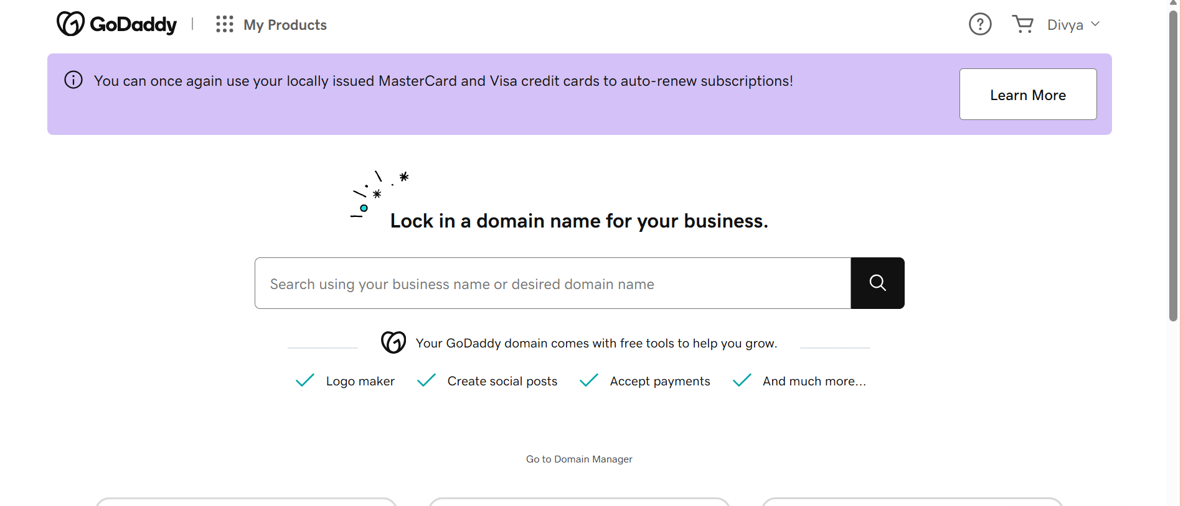
Step 2: Search for a Domain Name
Examples:
mycloudproject.com
divyareddy.cloud
awslearninglab.com
mydevopsdemo.site
- Enter the desired domain name in the search box.
- Click Search Domain.
Take a screenshot showing:
- Domain searched
- Availability status

Step 3: Select a Domain
Choose an available domain.
Example:
mydevopsdemo.site
Common domain extensions:
Extension | Usage
.com | Commercial websites
.net | Networks and IT
.org | Organizations
.site | Testing/Labs
.online | Personal projects
.tech | Technical projects
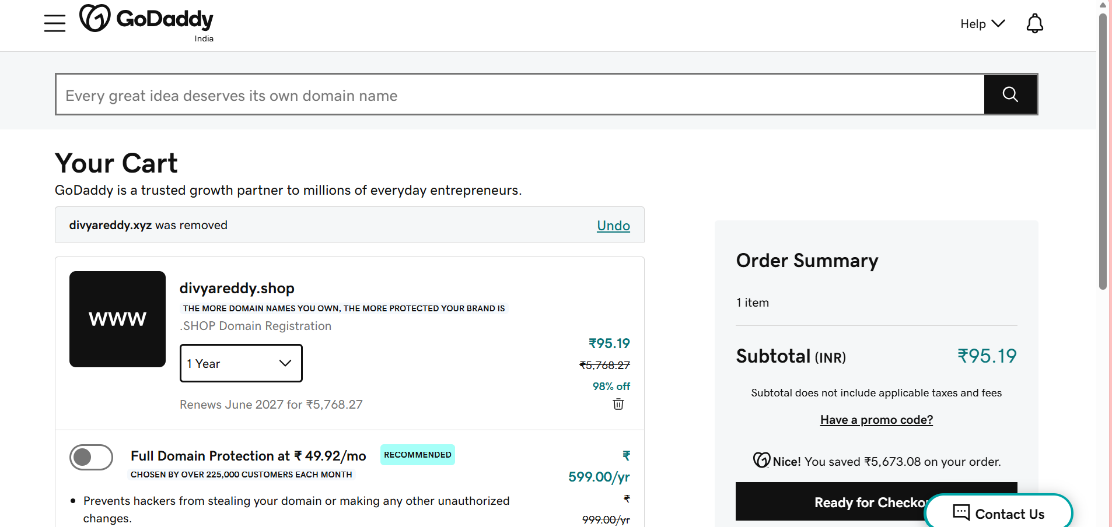
Step 4: Add Domain to Cart
Click:
Add to Cart
GoDaddy may offer:
- Email Hosting
- SSL Certificates
- Website Builder
- Microsoft 365
For lab purposes:
Select "No Thanks" for optional add-ons
Take a screenshot of the cart page.

Step 5: Configure Registration Period
Choose:
1 Year
or
2 Years
Recommended for assignments:
1 Year

Step 6: Complete Payment
Click:
Proceed to Checkout
Provide:
- Billing Address
- Payment Method
- GST Details (if applicable)
Complete payment.
Take a screenshot of:
- Order Summary
- Purchase Confirmation
(Do not expose payment details.)
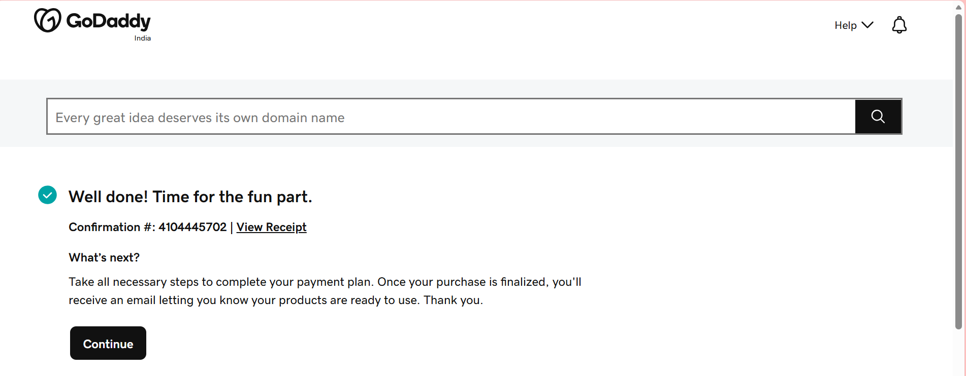
Step 7: Verify Domain Ownership
Navigate:
My Products
→ Domains
Verify the purchased domain appears.
Example:
mydevopsdemo.site
Take a screenshot showing:
- Domain name
- Expiry date
- Ownership status
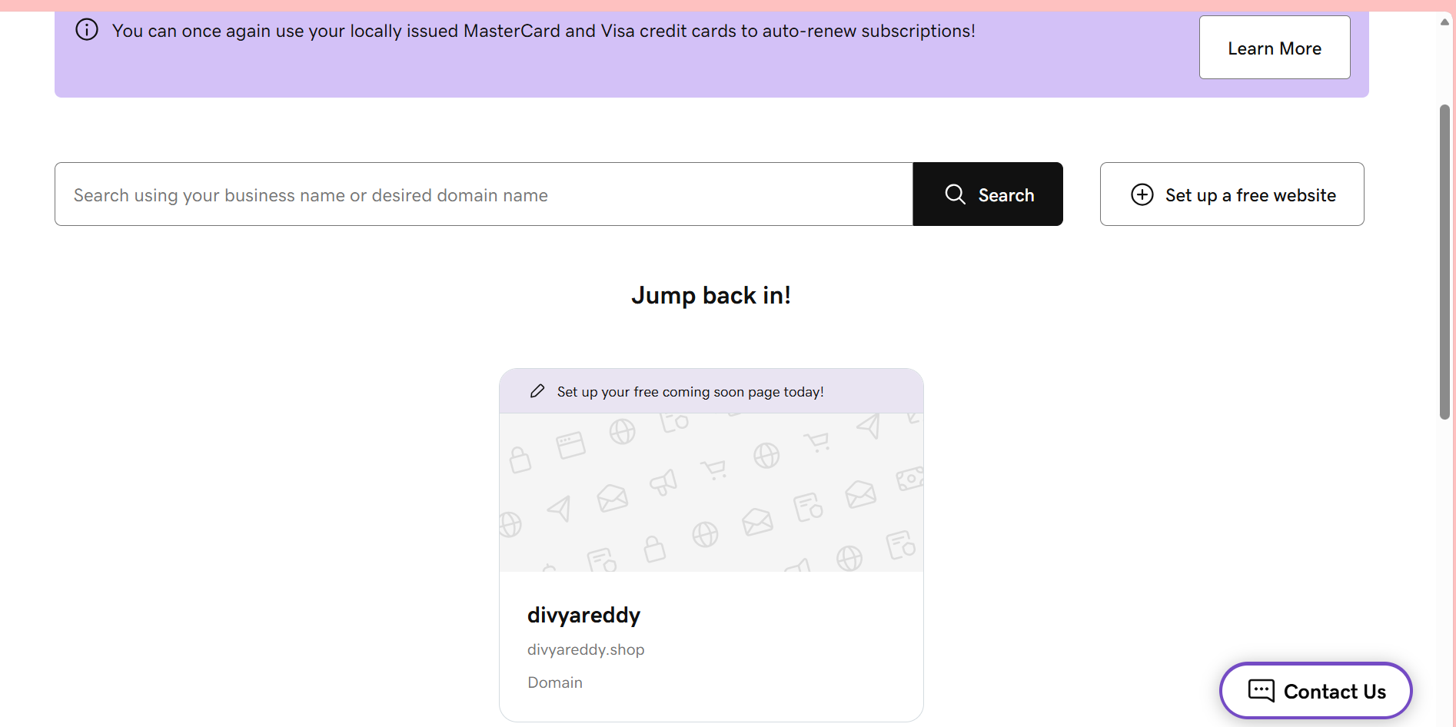
Step 8: Access DNS Management
Navigate:
Domains
→ Manage DNS
You should see:
A Record
CNAME Record
TXT Record
NS Records
SOA Record
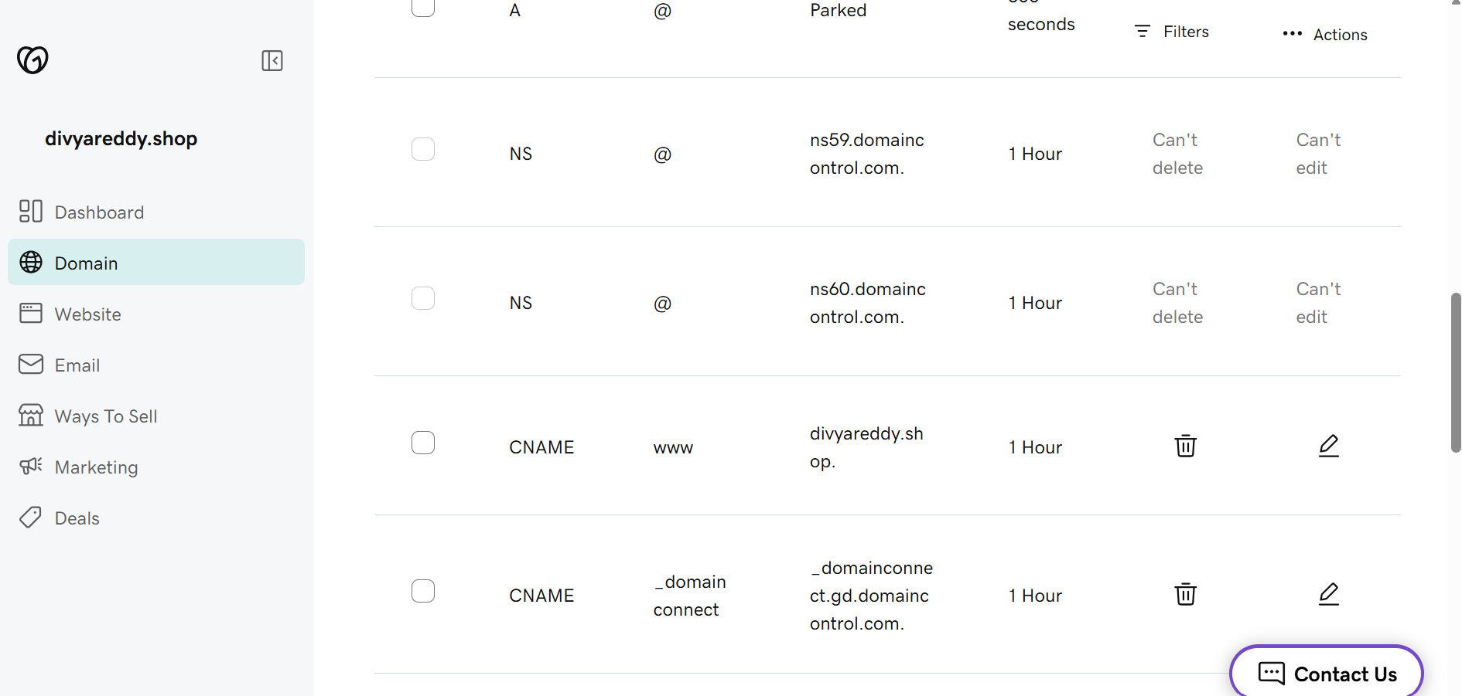
Task 3: Deploy a Static Website in Amazon S3
Objective
Host a static website using an Amazon S3 bucket and access it through a public website URL.

Architecture
User Browser
│
▼
S3 Static Website Hosting
│
▼
index.html
error.html

Prerequisites
- AWS Account
- S3 Permissions
- HTML files ready for upload

Step 1: Create an S3 Bucket
Navigate:
AWS Console
→ S3
→ Create Bucket
Configuration:
Bucket Name:
divyareddy-static-site
Region:
ap-south-1 (Mumbai)
Object Ownership:
ACLs Disabled
Block Public Access:
Uncheck "Block all public access"
Acknowledge the warning.
Click:
Create Bucket
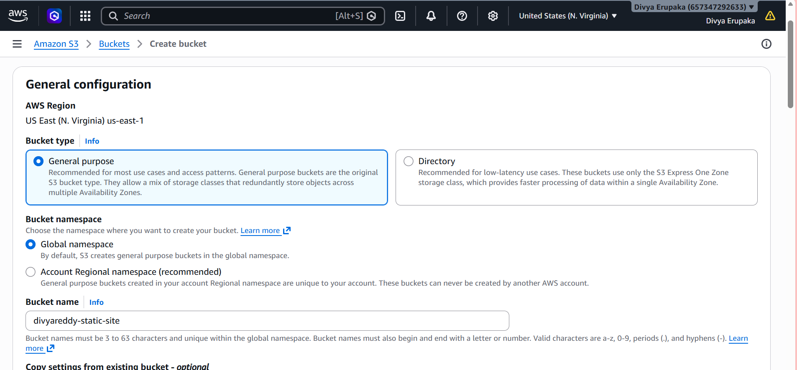
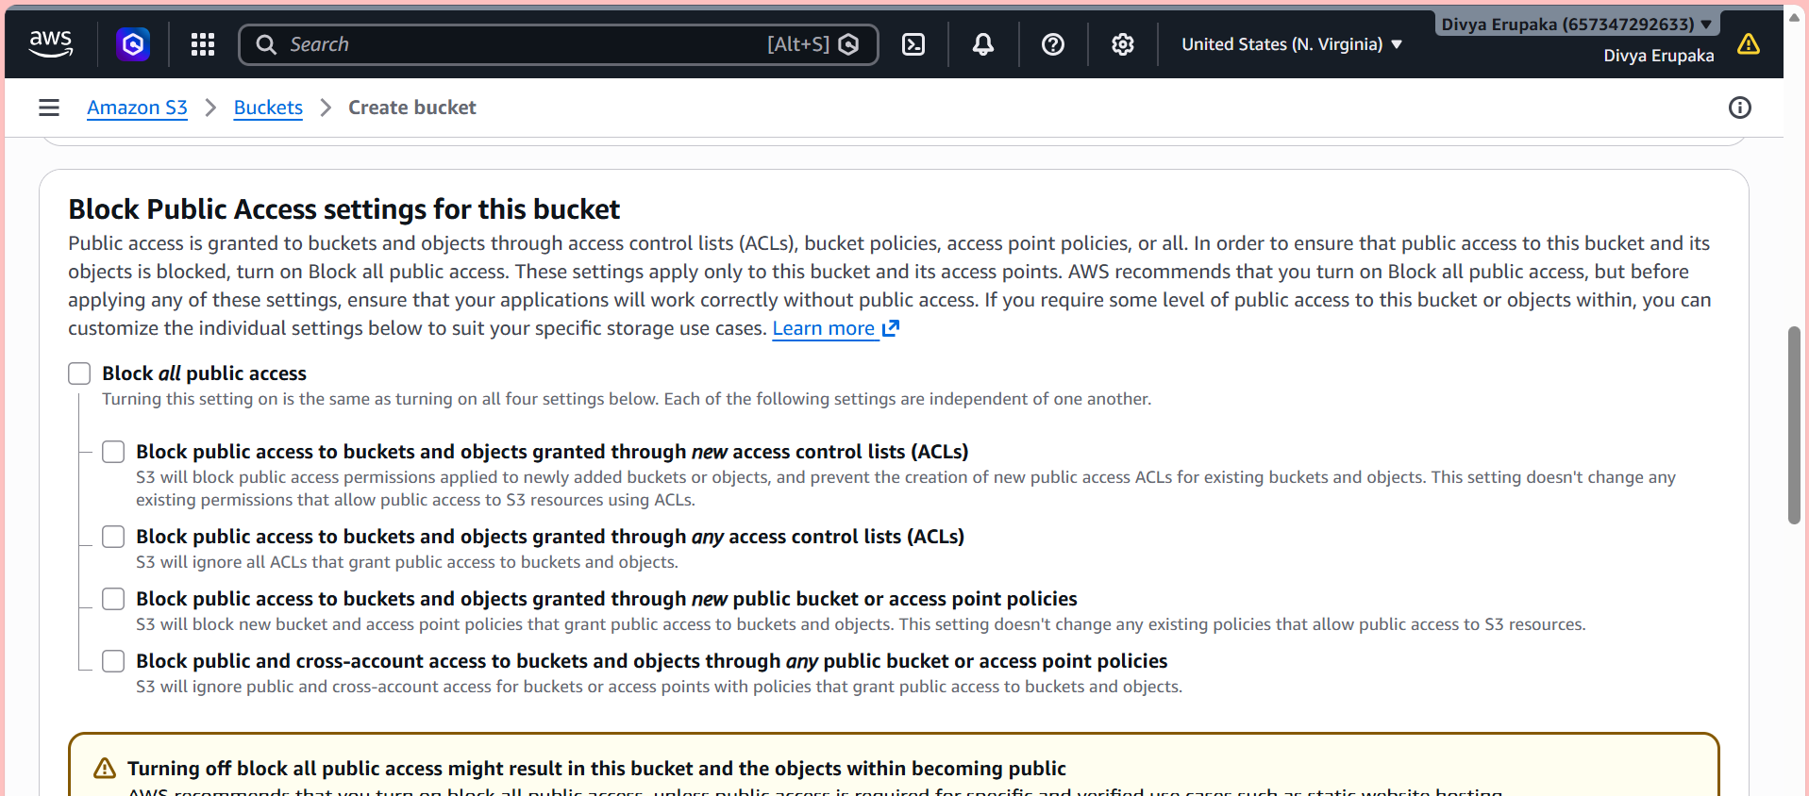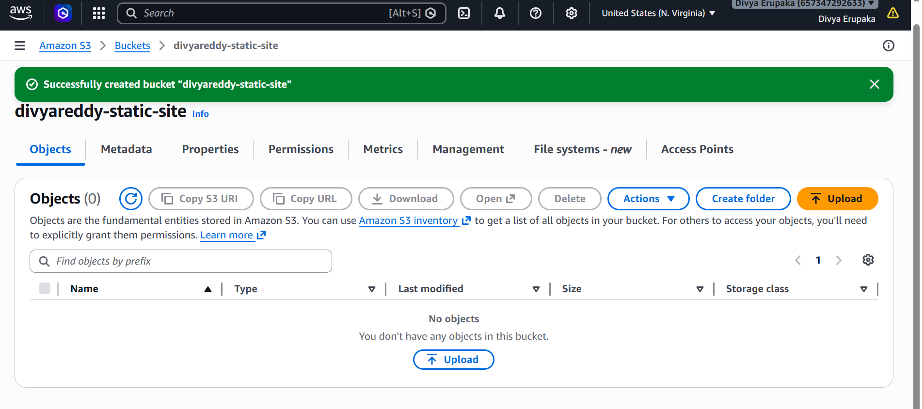
Step 2: Create Website Files
index.html
Create a file named:
<!DOCTYPE html>
<html>
<head>
<title>My AWS Static Website</title>
</head>
<body>
<h1>Welcome to My Static Website</h1>
<h2>Hosted on Amazon S3</h2>
<p>Created by Divya Reddy</p>
</body>
</html>

error.html
<!DOCTYPE html>
<html>
<head>
<title>Error</title>
</head>
<body>
<h1>404 - Page Not Found</h1>
</body>
</html>

Step 3: Upload Website Files
Open Bucket:
divyareddy-static-site
Click:
Upload
Upload:
index.html
error.html
Click:
Upload
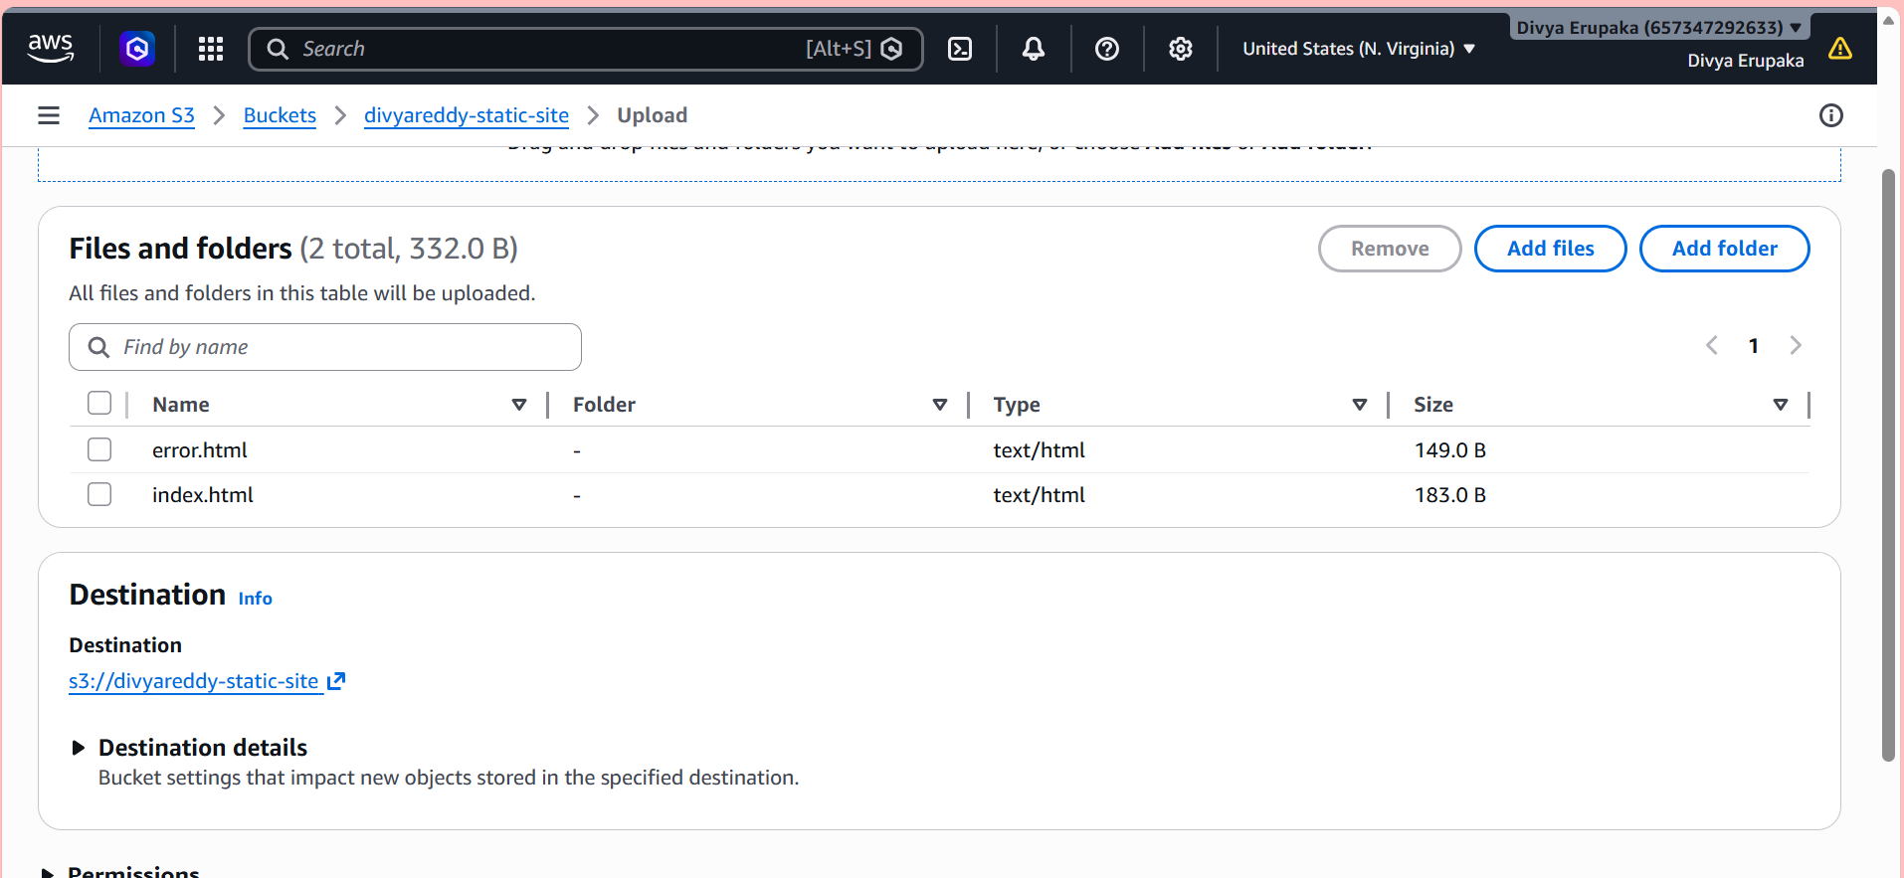
Step 4: Enable Static Website Hosting
Navigate: Bucket
→ Properties
→ Static Website Hosting
Click:Enable
Configuration:
Hosting Type:Host a static website
Index Document:index.html
Error Document:error.html
Save Changes.
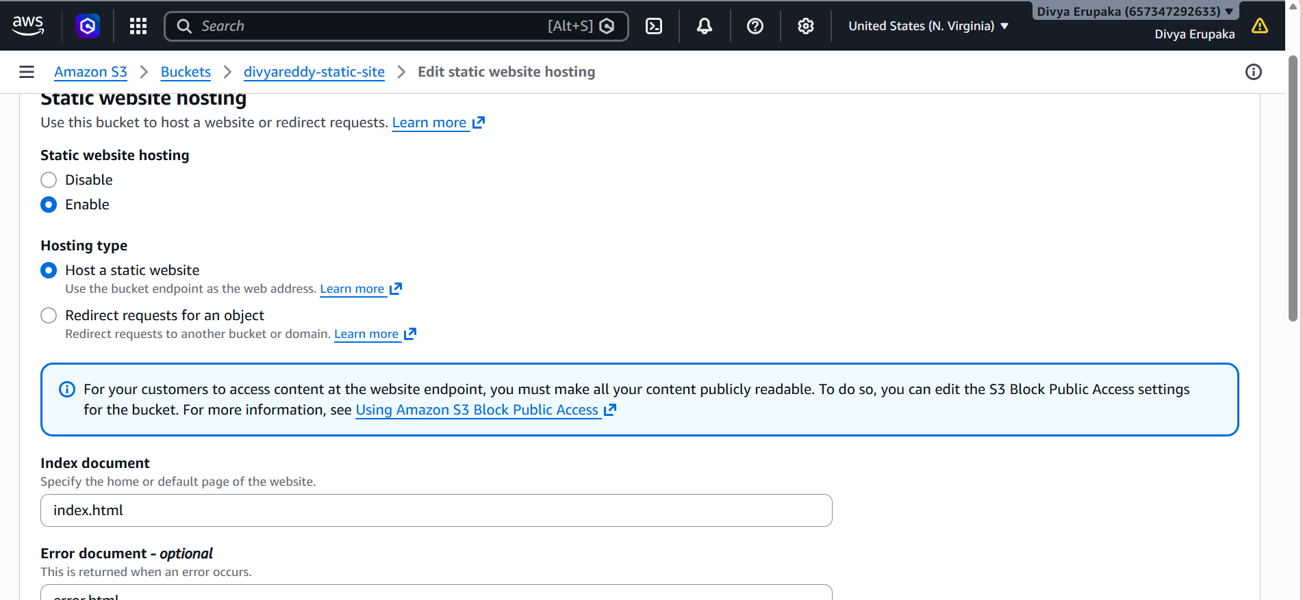Step 5: Add Bucket Policy
Navigate:
Permissions
→ Bucket Policy
Replace bucket name accordingly.
{
"Version": "2012-10-17",
"Statement": [
{
"Sid": "PublicReadAccess",
"Effect": "Allow",
"Principal": "*",
"Action": "s3:GetObject",
"Resource": "arn:aws:s3:::divyareddy-static-site/*"
}
]
}
Save Policy.
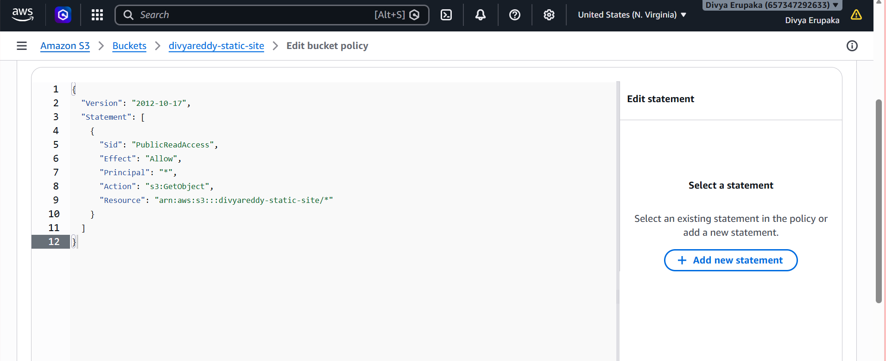
Step 6: Verify Public Access Settings
Navigate:
Permissions
→ Block Public Access
Verify:
Block all public access = OFF
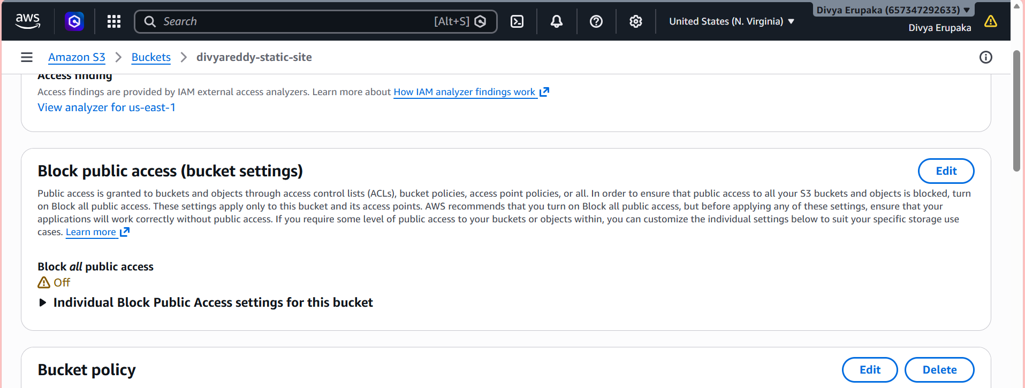
Step 7: Test Website
Navigate:
Properties
→ Static Website Hosting
Copy:
Bucket Website Endpoint
Example:
http://divyareddy-static-site.s3-website.ap-south-1.amazonaws.com
Open in browser.
Expected Output:
Welcome to My Static Website
Hosted on Amazon S3
Created by Divya Reddy
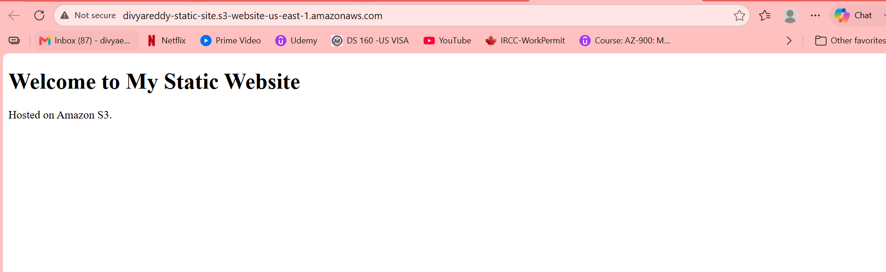
Task 4: Create a CloudFront CDN and Attach an SSL Certificate
Objective: Create an AWS CloudFront distribution for your S3 static website and secure it with an SSL certificate using AWS Certificate Manager (ACM).

Architecture
User
│
HTTPS
│
▼
CloudFront Distribution
│
▼
S3 Static Website

Prerequisites
Completed:
✅ Domain purchased from GoDaddy (e.g., divyareddy.xyz)
✅ Static website deployed in S3
✅ S3 Website Endpoint available

Step 1: Request SSL Certificate
Navigate
AWS Console
→ Certificate Manager (ACM)
Important:
Switch Region to:
us-east-1 (N. Virginia)
CloudFront only uses ACM certificates from us-east-1.

Request Certificate
Click:
Request Certificate
Select:
Public Certificate
Enter domain names:
divyareddy.xyz
*.divyareddy.xyz
Click:
Next
Validation Method:
DNS Validation
Click:
Request
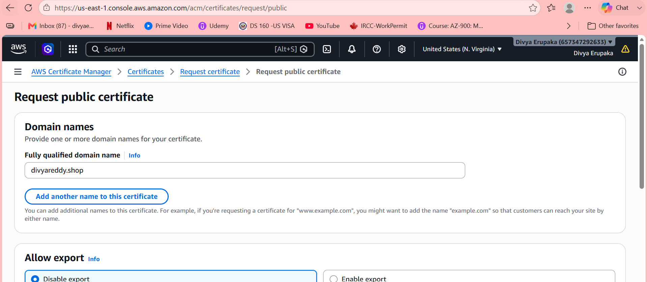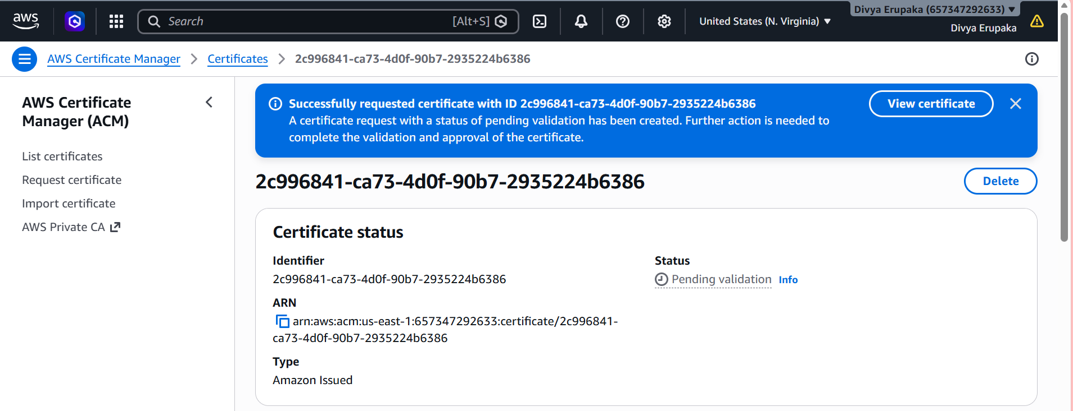
Step 2: Validate Certificate
ACM will provide CNAME records.
Example:
Type | Name | Value
CNAME | _abc.divyareddy.xyz | xyz.acm-validations.aws
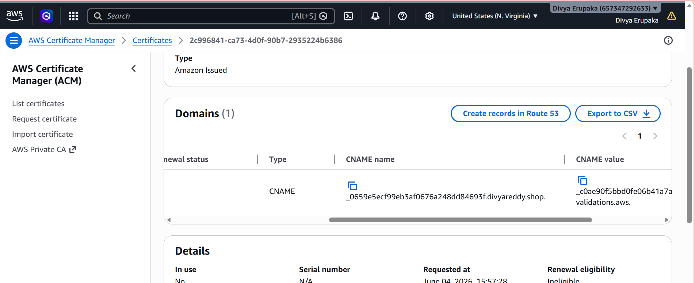
Add DNS Record in GoDaddy
Navigate:
GoDaddy
→ My Products
→ Domain
→ DNS Management
Click:
Add Record
Create ACM-provided CNAME record.
Save.
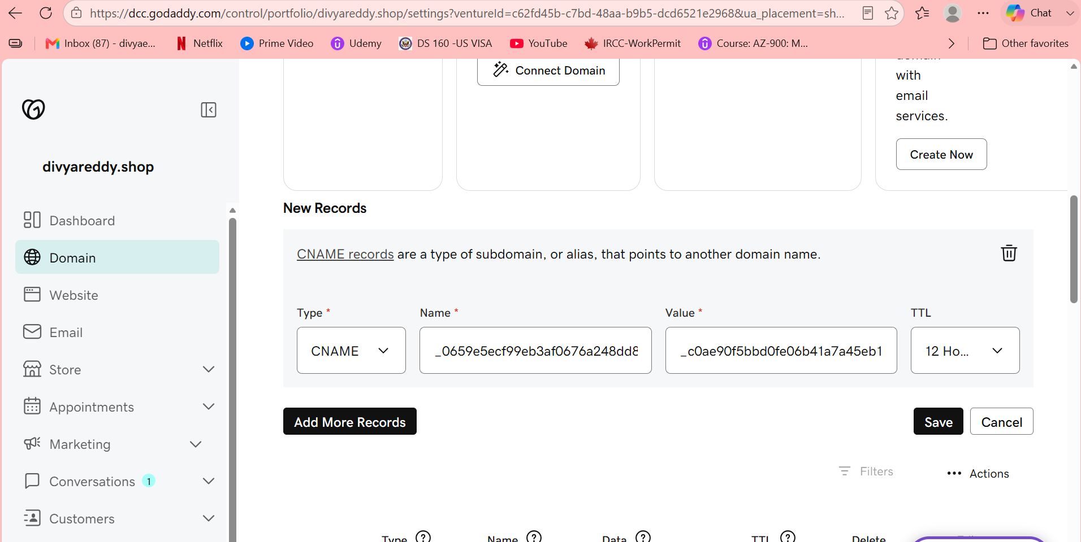
Wait for Validation
Usually:
5–15 minutes
Status changes to:
Issued
Screenshot Required
- ACM Certificate
- Status = Issued
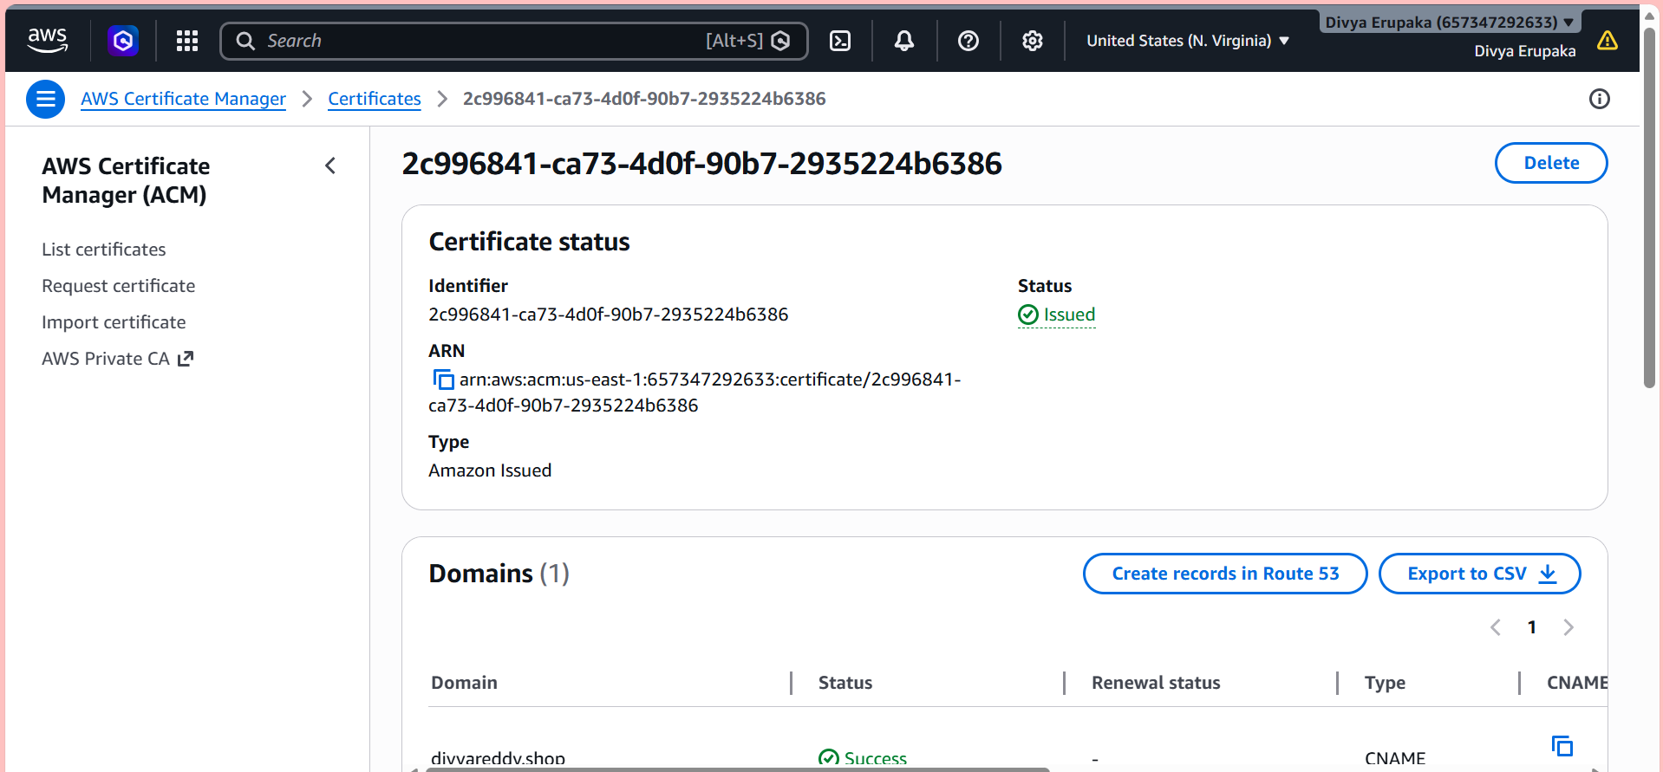
Step 3: Create CloudFront Distribution
Navigate:
AWS Console
→ CloudFront
→ Create Distribution
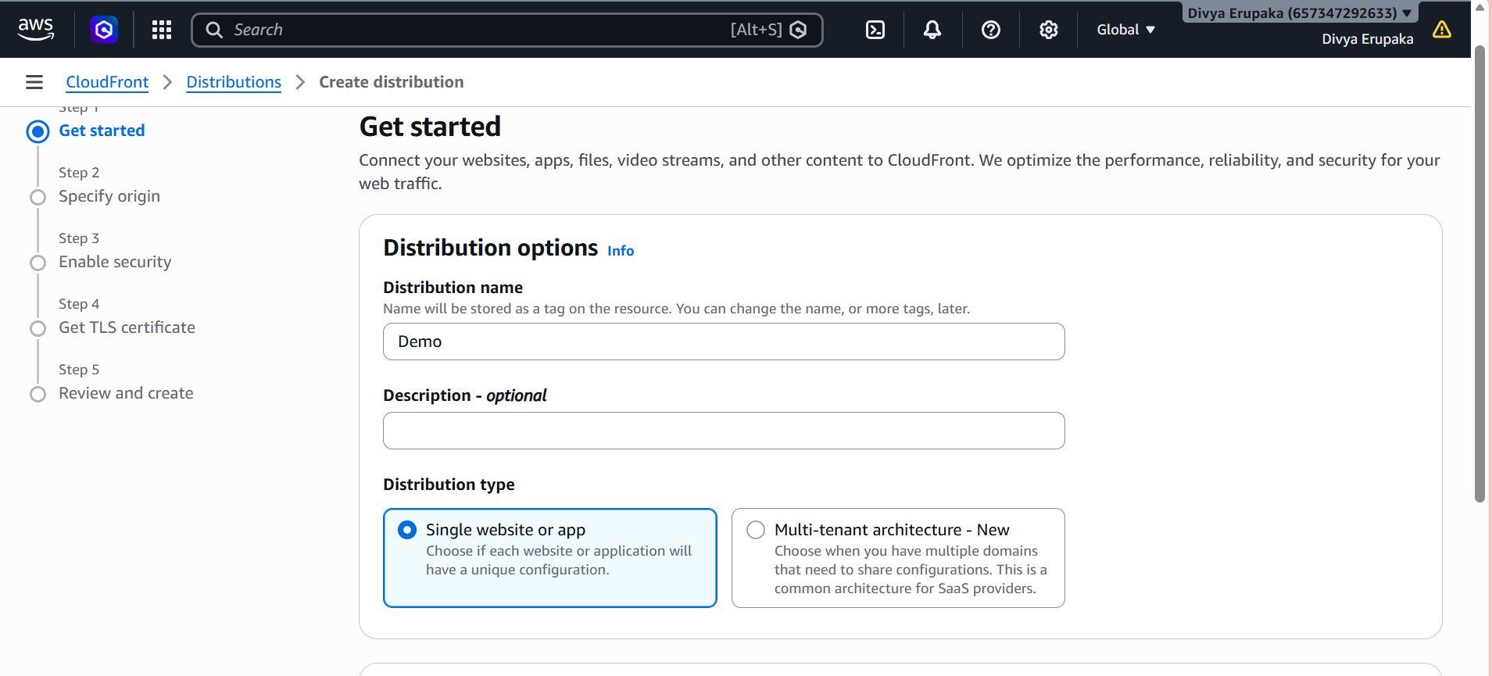
Origin Configuration
For Origin Domain:
Select:
S3 Website Endpoint
Example:
divyareddy-static-site.s3-website-ap-south-1.amazonaws.com

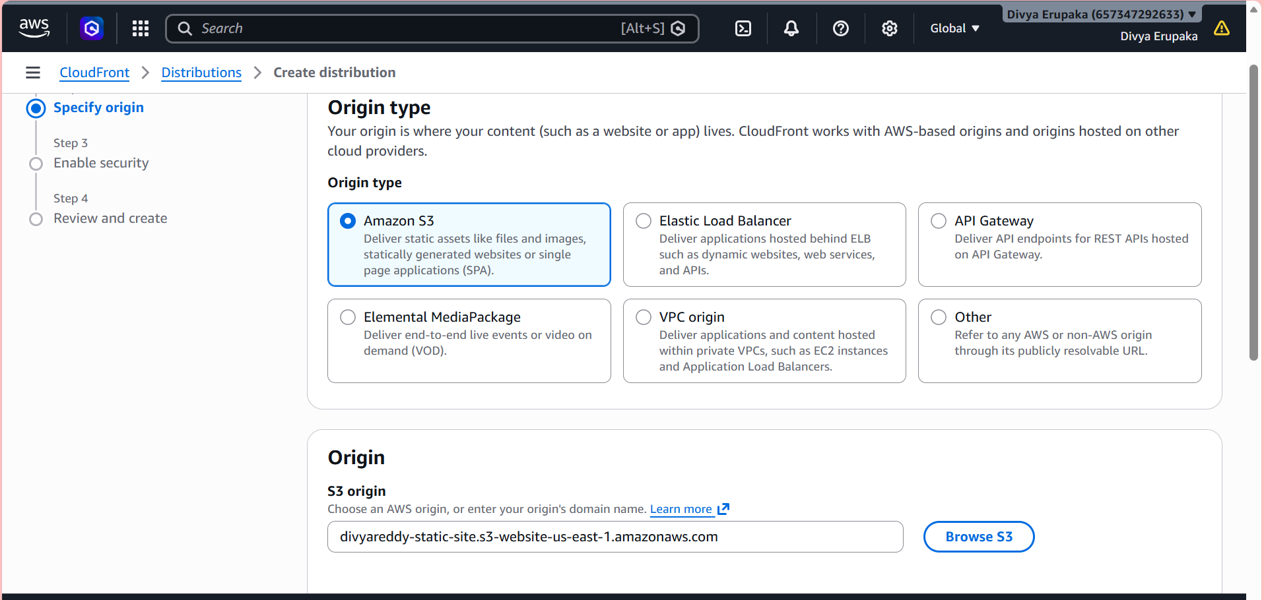
Do NOT select the regular S3 bucket endpoint.

Default Cache Behavior
Viewer Protocol Policy:
Redirect HTTP to HTTPS

Settings
Alternate Domain Name (CNAME):
divyareddy.xyz
Default Root Object:
index.html

SSL Certificate
Select:
Custom SSL Certificate
Choose:
divyareddy.xyz

Click:
Create Distribution
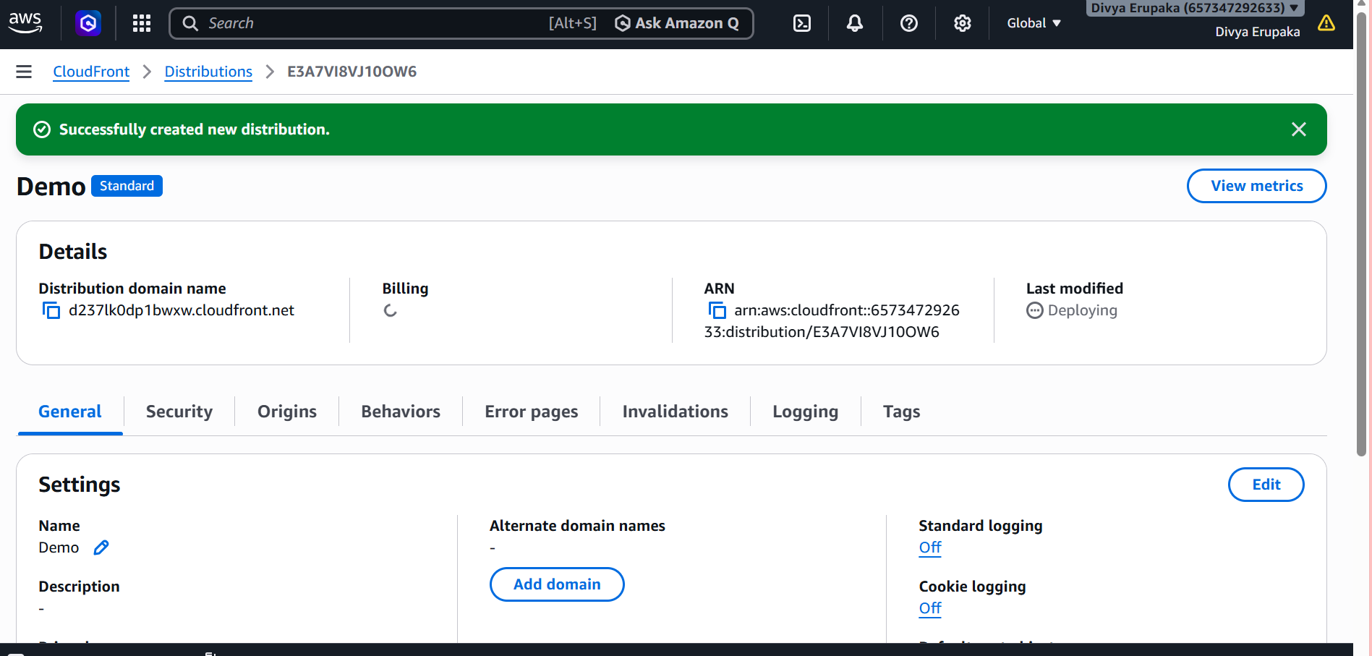
Step 4: Wait for Deployment
CloudFront Status:
Deploying
Wait:
10-20 minutes
Status becomes:
Enabled
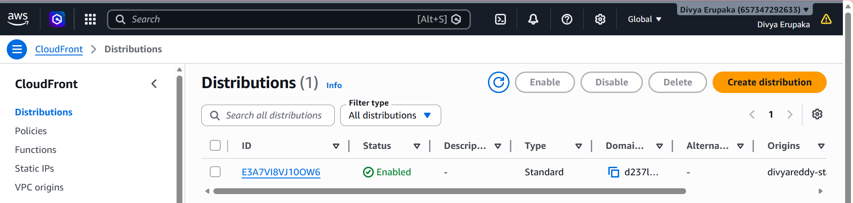
Step 5: Test CloudFront URL
CloudFront generates a URL:
Example:
https://d123abcxyz.cloudfront.net
Open it in browser.
Expected:
Welcome to My Static Website
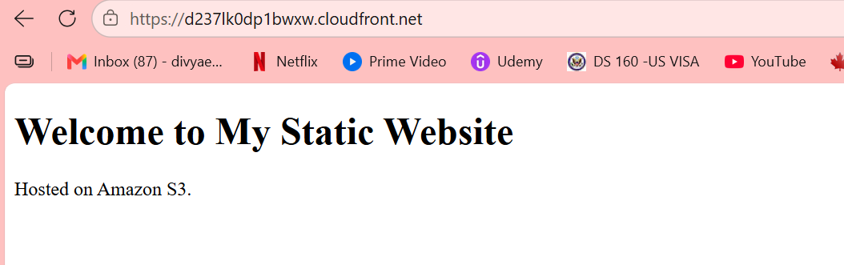
Step 6: Point Domain to CloudFront
Since your DNS is managed by GoDaddy, create a CNAME record.
Navigate:
GoDaddy
→ DNS Management
Create:
Type | Name | Value
CNAME | www | d123abcxyz.cloudfront.net
Save.

Root Domain Option
For:
divyareddy.xyz
you should ideally move DNS to Route 53 in the next task and create an Alias record.
For now:
www.divyareddy.xyz
is sufficient.
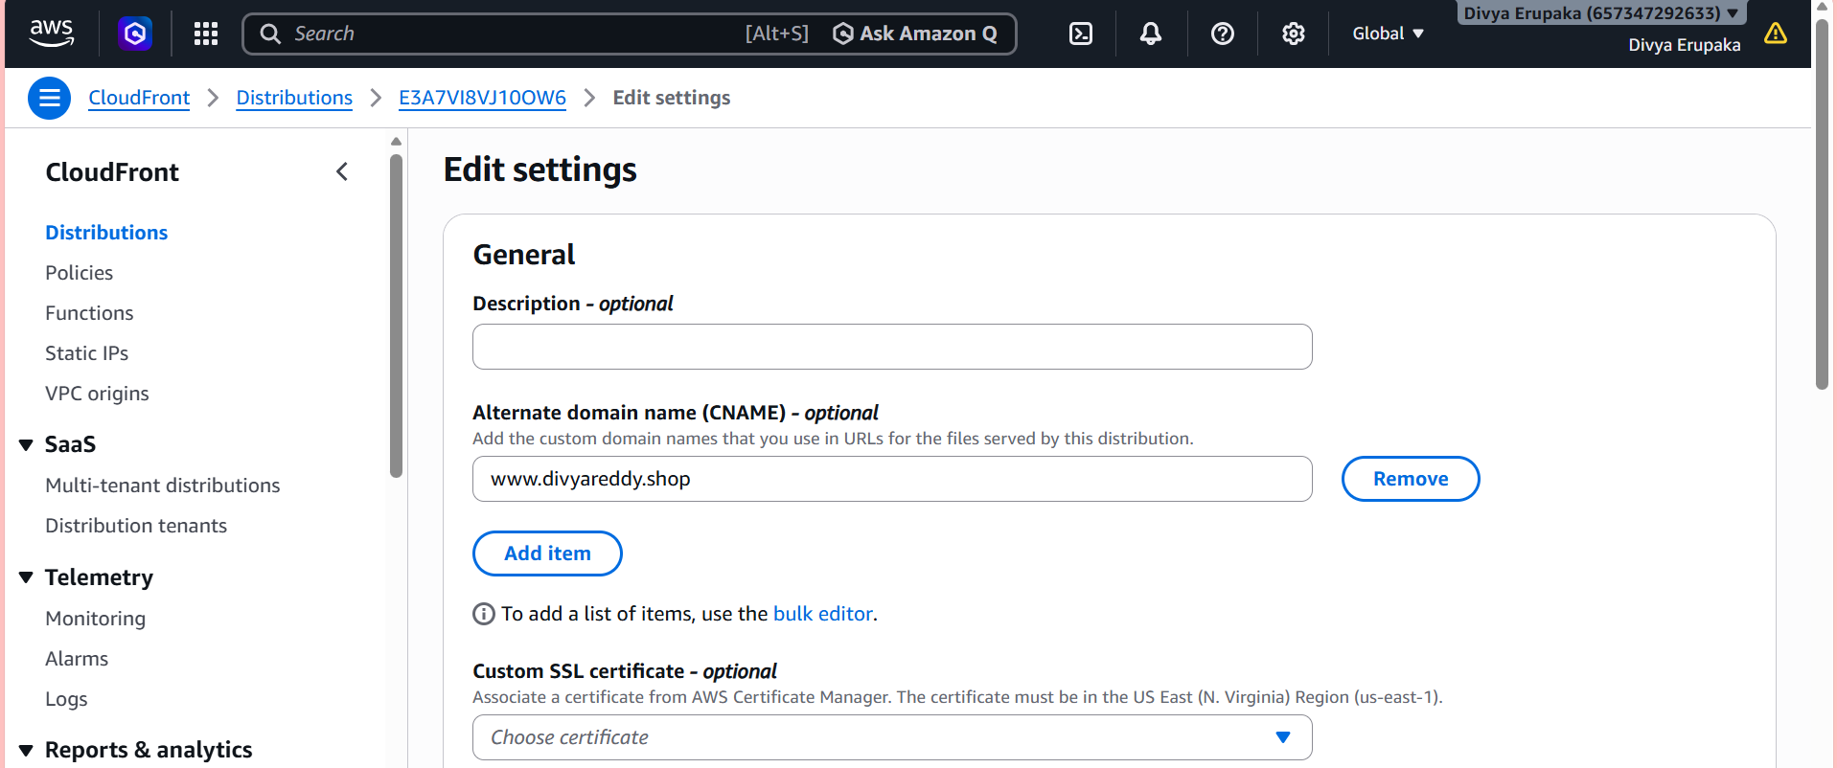
Step 7: Verify HTTPS
Open:
https://www.divyareddy.xyz
Verify:
✅ Website loads
✅ Browser shows lock icon
✅ SSL certificate valid
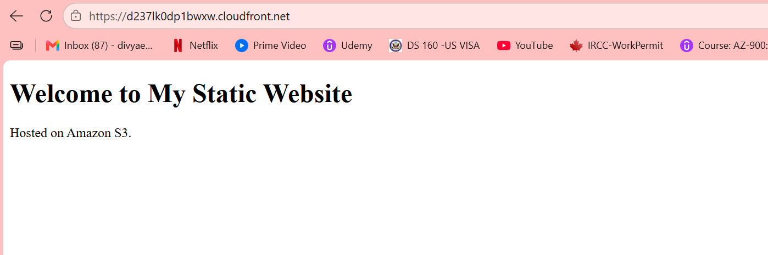
Task 5: Create a Route 53 Hosted Zone and Map the Domain to CloudFront CDN
Objective : Connect your GoDaddy domain divyareddy.shop to your CloudFront distribution using Route 53.

Current Architecture
divyareddy.shop
↓
GoDaddy DNS
↓
CloudFront CDN
↓
S3 Static Website
Final Architecture
divyareddy.shop
↓
Route 53 Hosted Zone
↓
CloudFront CDN
↓
S3 Static Website

Step 1: Create a Hosted Zone
Navigate:
AWS Console
→ Route 53
→ Hosted Zones
→ Create Hosted Zone
Enter:
Domain Name:
divyareddy.shop
Type:
Public Hosted Zone
Click:
Create Hosted Zone
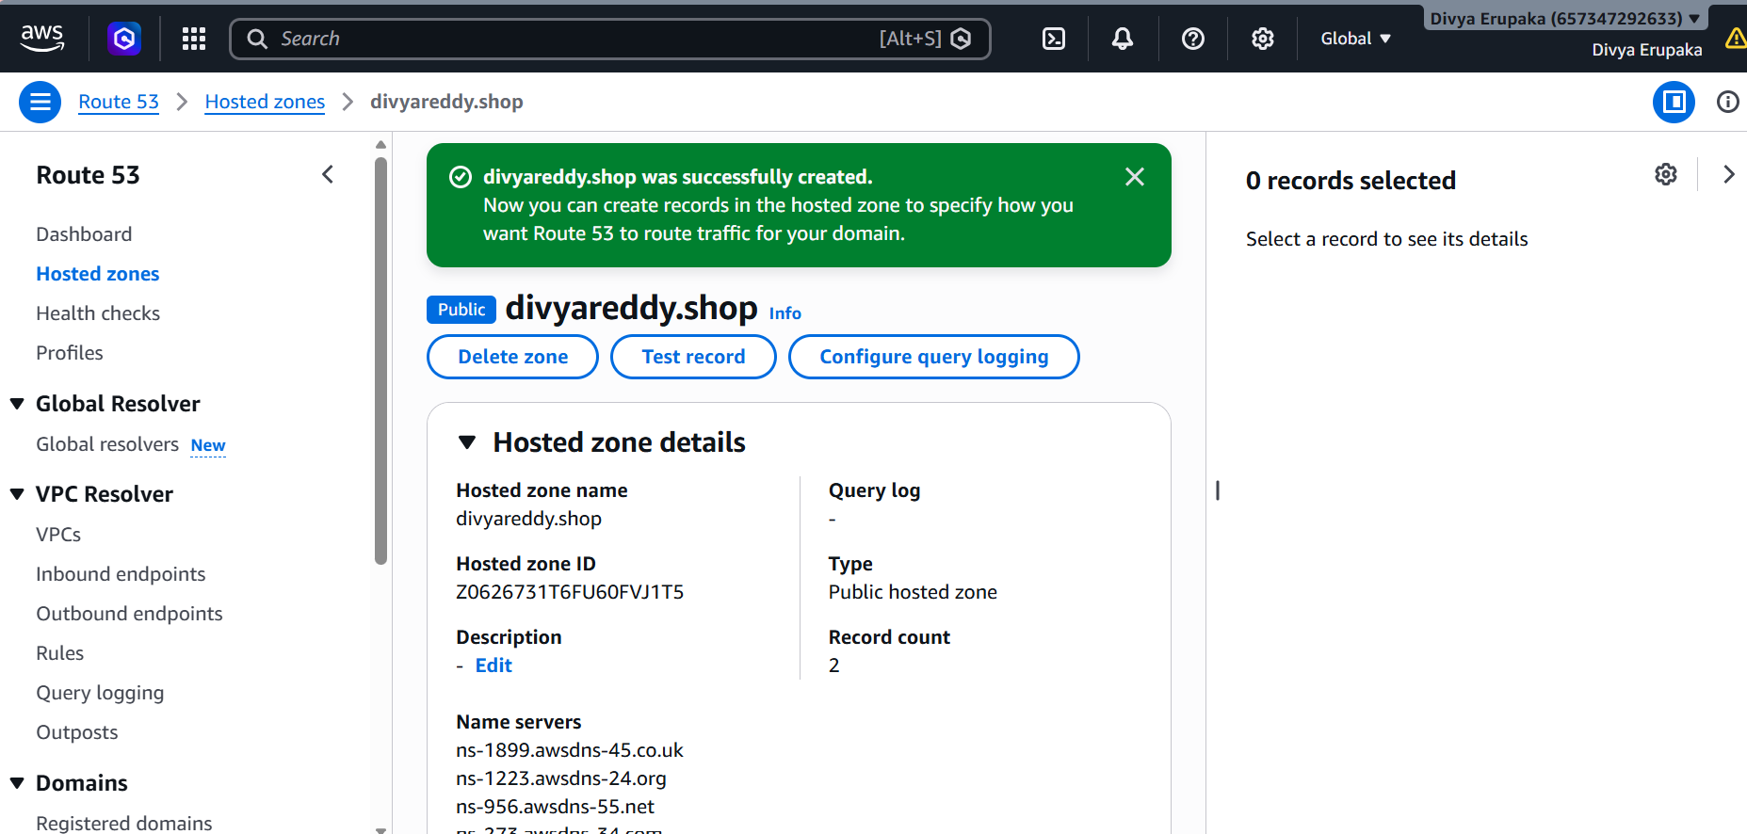
Step 2: Copy Route 53 Name Servers
After creation, Route 53 generates 4 NS records.
Example:
ns-123.awsdns-45.com
ns-456.awsdns-78.net
ns-789.awsdns-12.org
ns-111.awsdns-34.co.uk
Copy all 4.
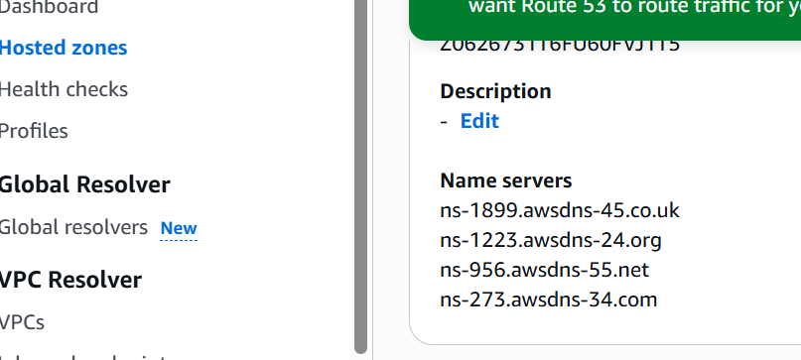
Step 3: Update GoDaddy Nameservers
Login to GoDaddy.
Navigate:
My Products
→ Domains
→ divyareddy.shop
→ Domain Settings
→ Nameservers
→ Change
Select:
I'll use my own nameservers
Paste the 4 Route 53 nameservers.
Example:
ns-123.awsdns-45.com
ns-456.awsdns-78.net
ns-789.awsdns-12.org
ns-111.awsdns-34.co.uk
Save.
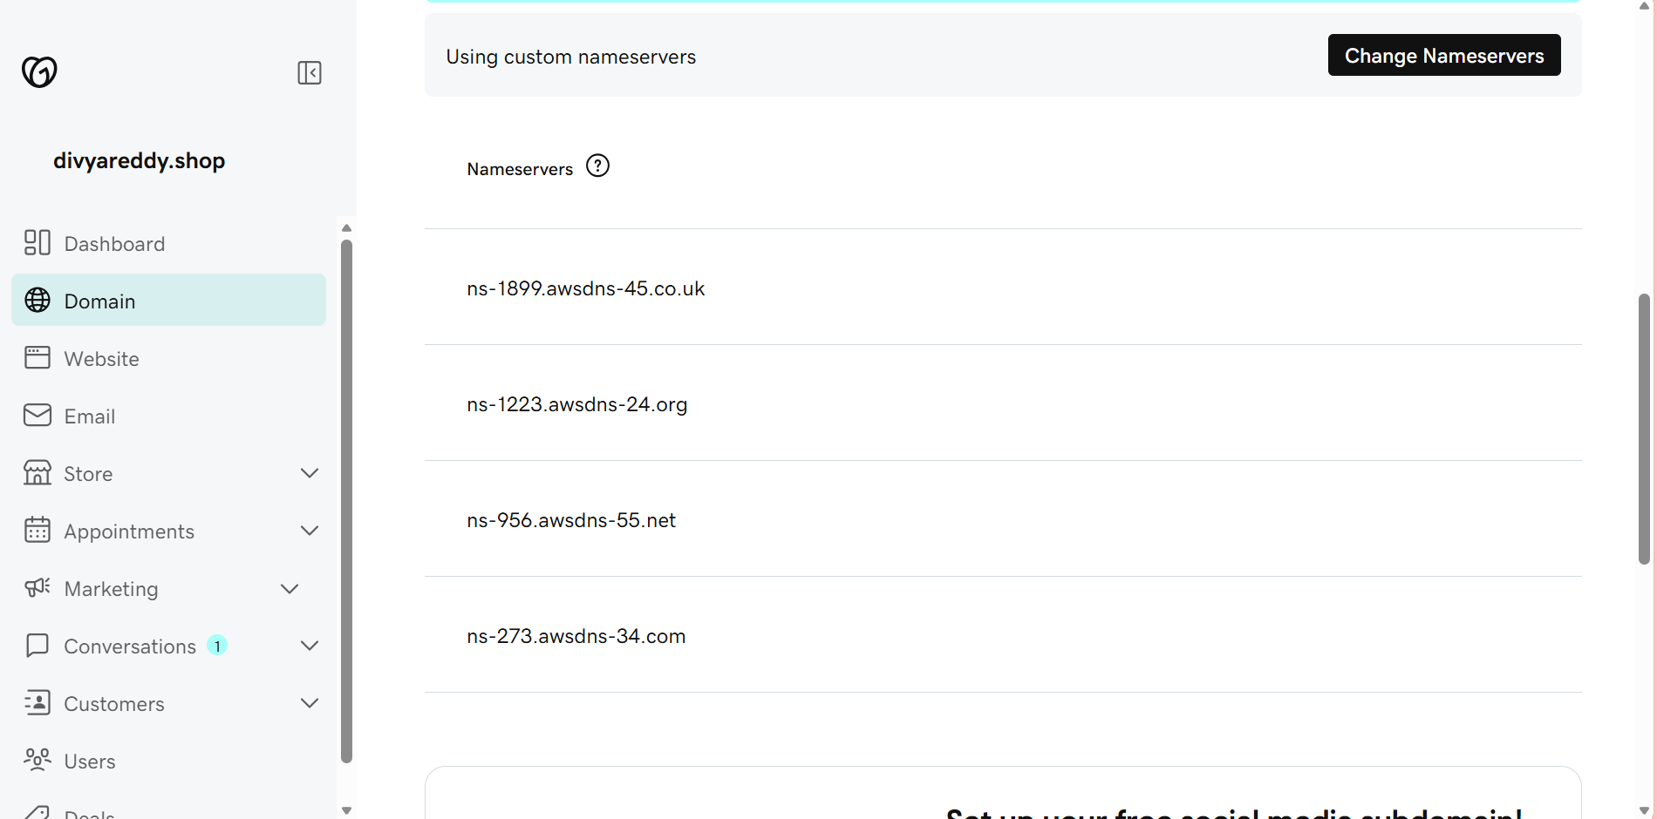
Step 4: Wait for DNS Propagation
Propagation usually takes:
15 minutes to 24 hours
Often completes within 30–60 minutes.
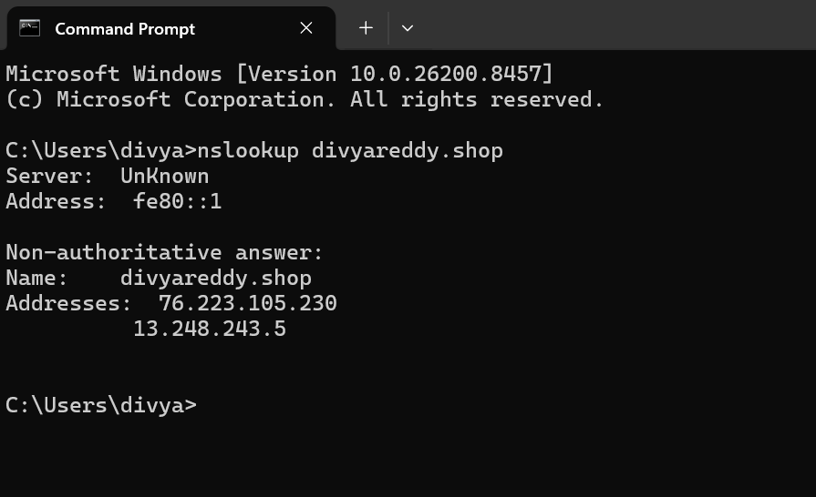
Step 5: Create Alias Record in Route 53
Open:
Route 53
→ Hosted Zones
→ divyareddy.shop
→ Create Record

Root Domain Record
Configure:
Record Name:
Leave Blank
Record Type:
A
Alias:
ON
Select:
Alias to CloudFront Distribution
Choose:
d237lk0dp1bwxw.cloudfront.net
Click:
Create Records
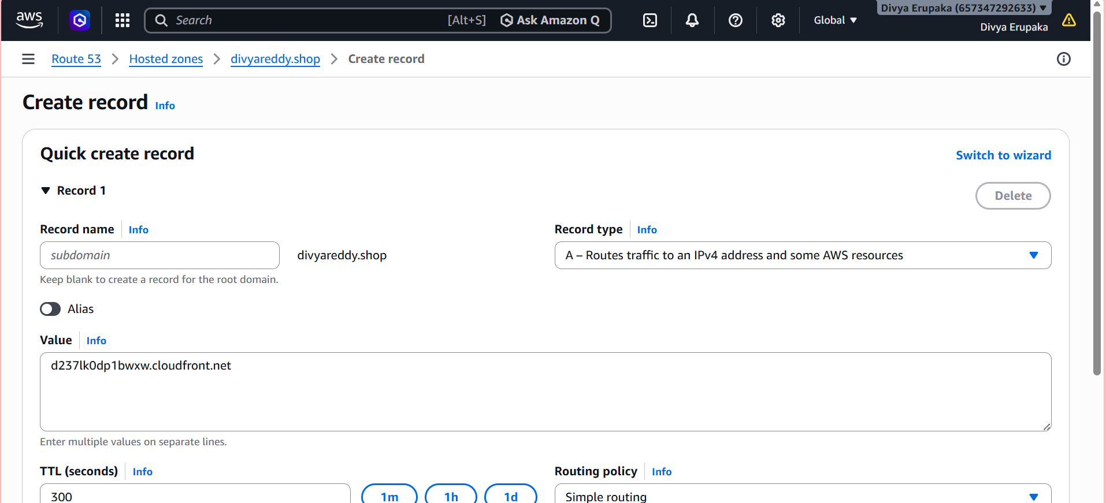
Step 6: Create WWW Record (Optional)
Create another record.
Record Name:
www
Record Type:
A
Alias:
ON
Target:
d237lk0dp1bwxw.cloudfront.net
Save.
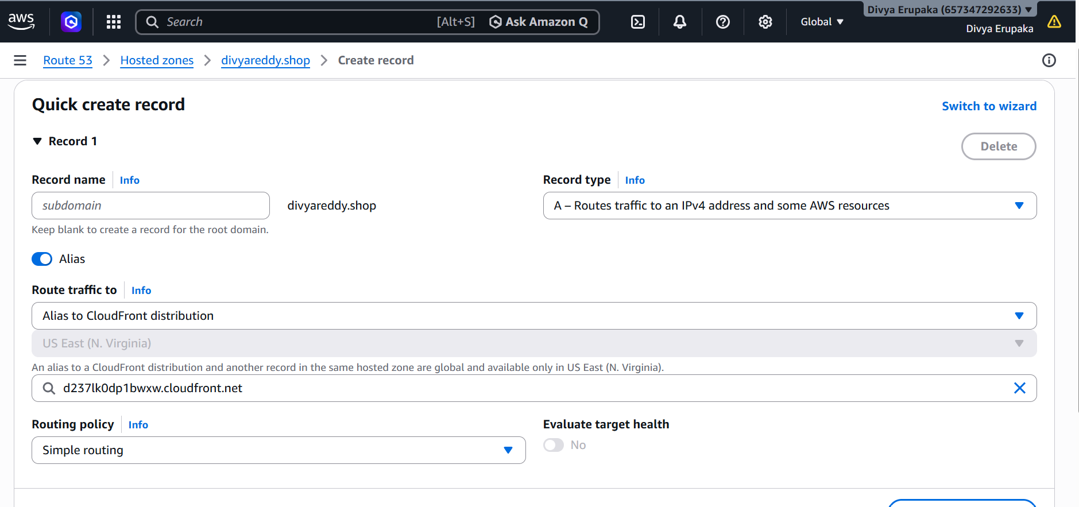
Step 7: Update CloudFront
Go to:
CloudFront
→ Distribution
→ Settings
→ Edit
Alternate Domain Names:
divyareddy.shop
If your ACM certificate includes www:
www.divyareddy.shop
Custom SSL Certificate:
divyareddy.shop
Save Changes.

Step 8: Verify DNS Resolution
Open:
https://divyareddy.shop
Expected:
Welcome to My Static Website
Hosted on Amazon S3
Created by Divya Reddy
Browser should display:
🔒 Secure
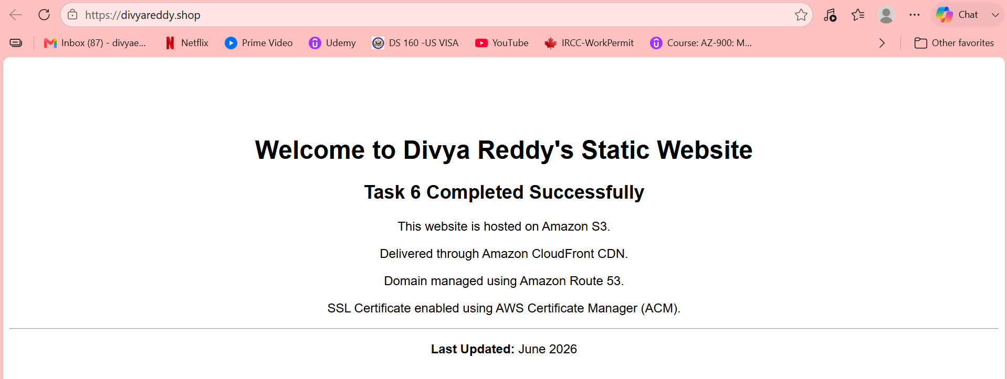
Task 6: Update the index.html in the S3 Bucket and Verify Access Through Domain
Objective
Update the existing index.html file in the S3 bucket and verify that the updated content is accessible using the custom domain configured through CloudFront and Route 53.

Step 1: Modify index.html
Create or update the existing index.html file with new content.
Example:
<!DOCTYPE html>
<html>
<head>
<title>Divya Reddy - Static Website</title>
</head>
<body>
<h1>Welcome to Divya Reddy's Static Website</h1>
<h2>Task 6 Completed Successfully</h2>
<p>This website is hosted on Amazon S3.</p>
<p>Delivered through Amazon CloudFront CDN.</p>
<p>Domain managed using Route 53.</p>
<p>Last Updated: June 2026</p>
</body>
</html>
Save the file as:
index.html

Step 2: Upload Updated File to S3
Navigate:
AWS Console → S3 → Bucket → Objects
Select:
index.html
Choose:
Upload
→ Add Files
→ Select Updated index.html
→ Upload
The existing file will be overwritten.
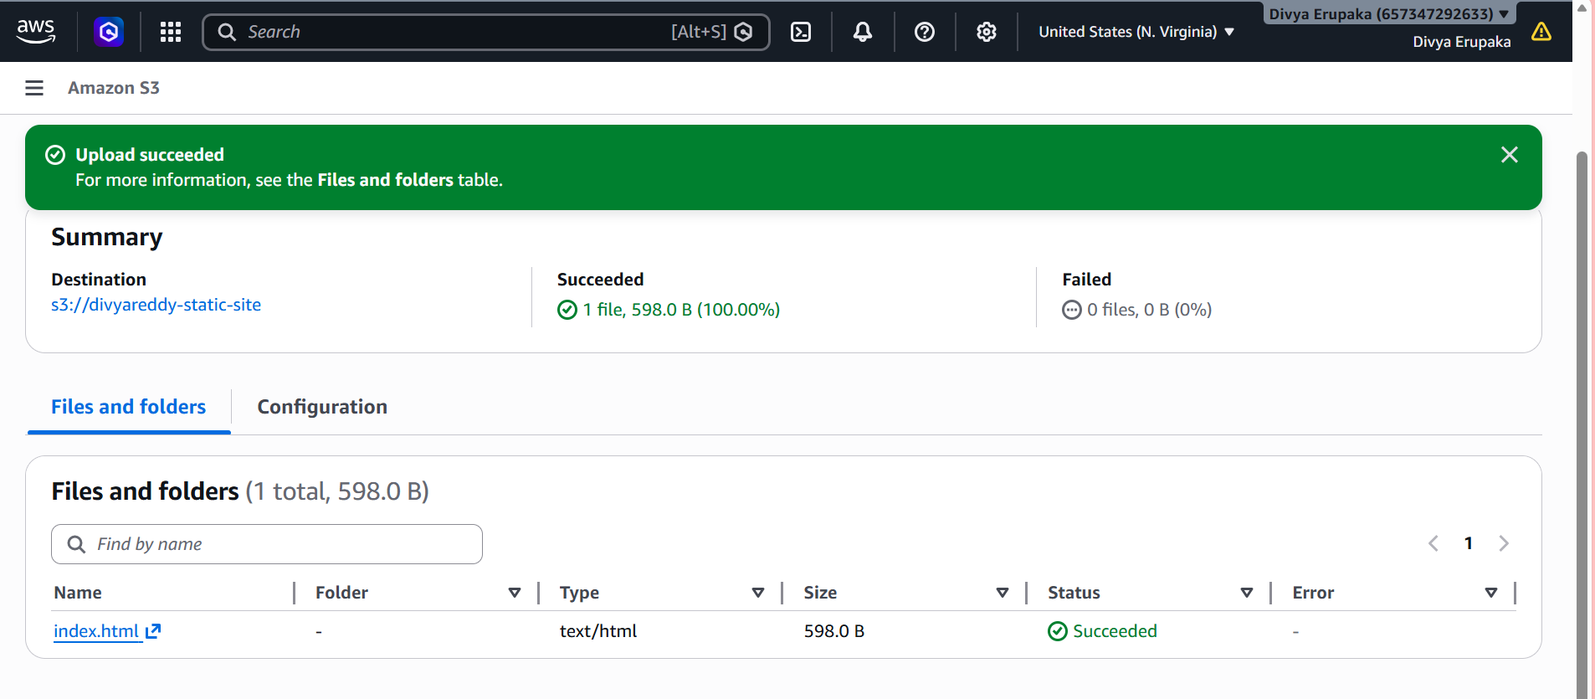
Step 3: Verify S3 Website Endpoint
Open the S3 Static Website URL.
Example:
http://<bucket-name>.s3-website-us-east-1.amazonaws.com
Verify the updated content is displayed.
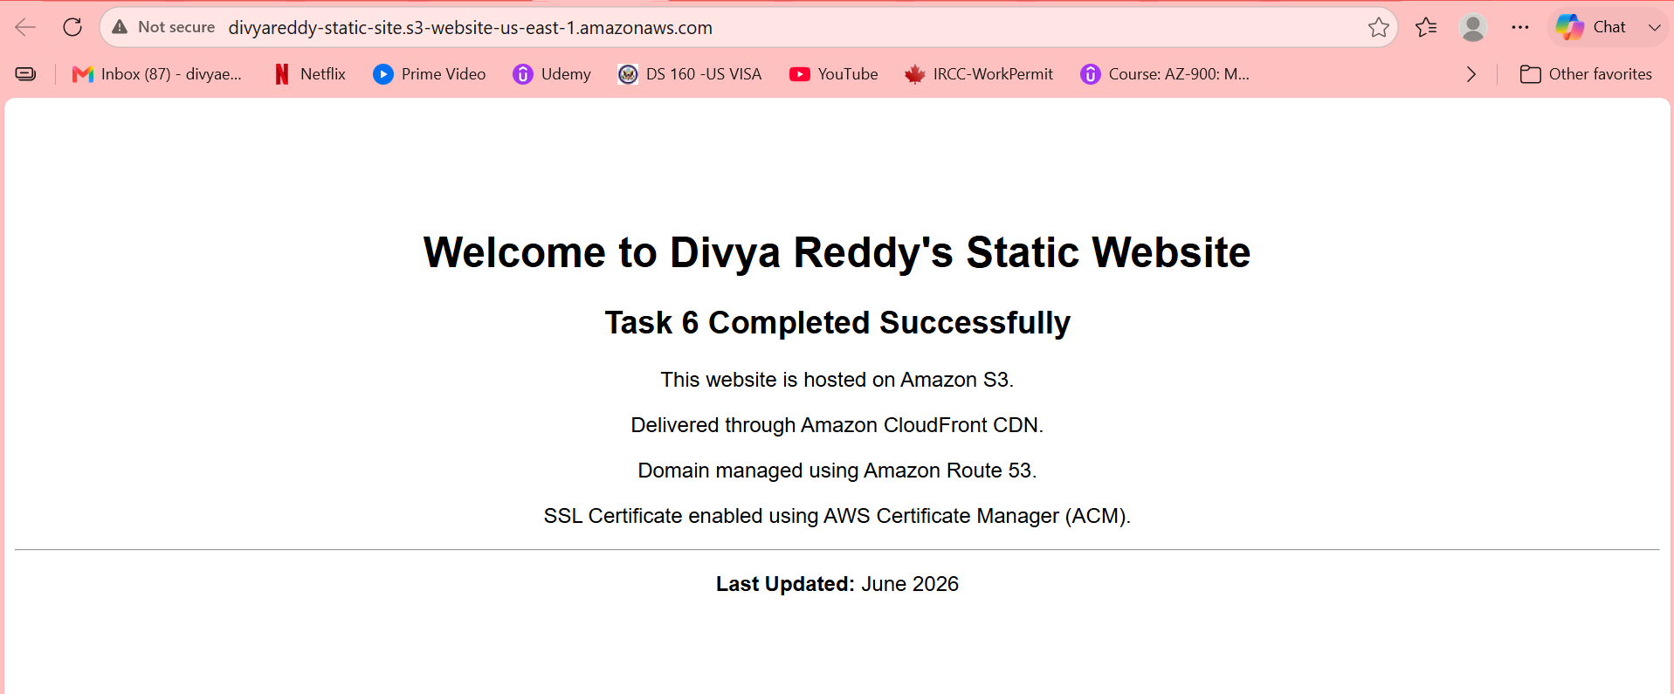
Step 4: Clear CloudFront Cache
Since CloudFront caches content, create an invalidation.
Navigate:
AWS Console → CloudFront → Distribution → Invalidations
Click:
Create Invalidation
Enter:
/*
Click:
Create Invalidation
Wait for the invalidation status to become Completed.
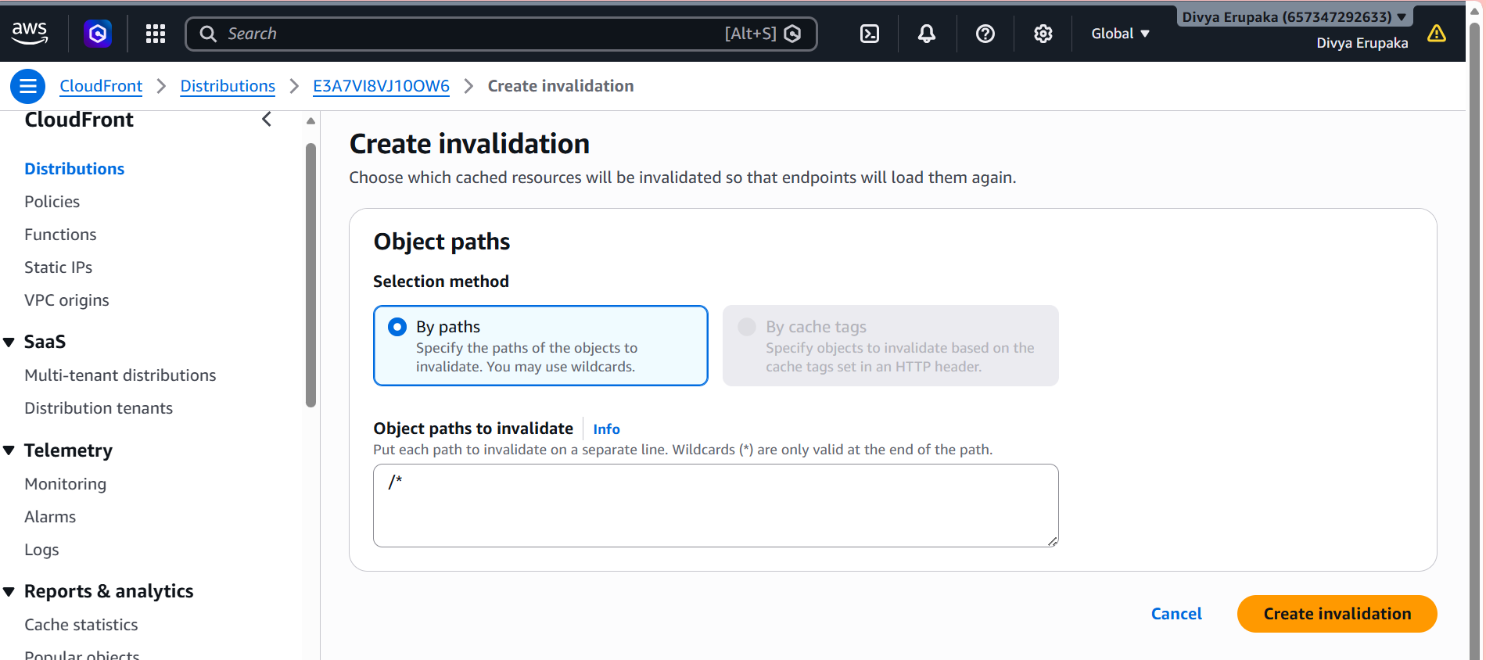
Step 5: Verify CloudFront URL
Open:
https://d237lk0dp1bwxw.cloudfront.net
Verify the updated website content is displayed.
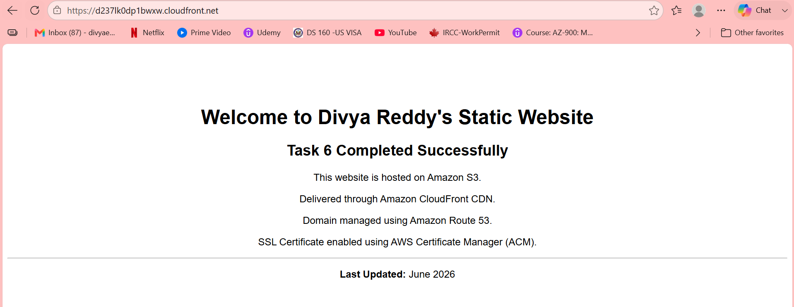
Step 6: Verify Custom Domain
Open:
https://divyareddy.shop
Verify the same updated content is displayed.

Task 8 – Connectivity Testing
The static website has been deployed successfully using Amazon S3, CloudFront CDN, Route 53, and ACM SSL Certificate.
Please verify connectivity using the URL below:
https://divyareddy.shop
Kindly confirm whether the website is accessible from your network and share any observations.
Thank you.

